**A Project Report on**

**“ONLINE JOB PORTAL”**

**Submitted in partial fulfillment of the requirement for**

**Degree in Bachelor of Engineering (Information Technology)**

**By**

Bryan Ronad (5019107)

Mithun Kuthully (5019131)

Rishita Mane (5019134)

**Guided by:**

Prof. Smita R.



**Department of Information Technology**

**Fr. Conceicao Rodrigues Institute of Technology**

Sector 9A, Vashi, Navi Mumbai – 400703

**University of Mumbai**

**2020-2021**

**CERTIFICATE**

This is to certify that the project entitled

**“ONLINE JOB PORTAL”**

**Submitted By**

Bryan Ronad (5019107)

Mithun Kuthully (5019131)

Rishita Mane (5019134)

In partial fulfillment of degree of **B.E**. in **Information Technology** for term work of the project is approved.

**_________________** **________________**

**External Examiner Internal Examiner**

**_________________**

**Internal Guide**

**__________________** **________________**

**Head of the Department Principal**

**Date: -**  **College Seal**

Declaration

We declare that this written submission represents our ideas in our own words and where others' ideas or words have been included, we have adequately cited and referenced the original sources. We also declare that we have adhered to all principles of academic honesty and integrity and have not misrepresented or fabricated or falsified any idea/data/fact/source in our submission. We understand that any violation of the above will be cause for disciplinary action by the Institute and can also evoke penal action from the sources which have thus not been properly cited or from whom proper permission has not been taken when needed.

----------------------------------------

Bryan Ronad(5019107)

-----------------------------------------

Mithun Kuthully(5019131)

-----------------------------------------

Rishita Mane (5019134)

Date:

**ABSTRACT**

Online Job Portal is a web application, which serves jobseekers to find available job vacancies and employers to identify the most qualified candidates. This Job Portal consists of three main users. Admin, Recruiter and Jobseeker. The admin has authority over the complete portal such as it can see applicant’s profile, recruiter’s criteria for hiring, etc. Recruiter can register their company on the portal, post and remove jobs, view jobseeker profile, download their CVs. Jobseeker can register on our portal and can search and apply for jobs matching their profile as well as upload their CV. Jobseekers can also give feedback on the recruiter’s company. The main aims of this portal are to connect to the industries and act as an online recruitment to support students to find the right job after graduation. Furthermore, this system enhances the understanding concept and importance of the job portal for students in the universities.

**INDEX**

|  |  |  |
| --- | --- | --- |
| **Sr. No.** | **Topic** | **Page No.** |
| 1 | Introduction | 8-10 |
| 2 | Literature Survey and Analysis   * Related work * Existing System * Requirements Analysis | 11-18 |
| 3 | System Design   * Architectural Diagram/ block diagram * Flow chart | 15-18 |
| 4 | Implementation details   * System Requirements (Software/Hardware) * Solution Approach/ Methodology | 19-22 |
| 5 | Experimental Results   * GUI | 23-39 |
| 6 | Conclusion and Future Scope   * Conclusion * Future Scope | 40-41 |
|  | References | 42 |
|  | Appendix A : Code Sample | 43-83 |
|  | Acknowledgements |  |

**LIST OF FIGURES**

|  |  |  |
| --- | --- | --- |
| **Sr. No.** | **Name of the Figure** | **Page No.** |
| 1 | Architectural Block Diagram | 16 |
| 2 | Flowchart | 18 |
| 3 | Home Page | 24-25 |
| 4 | Admin Page | 26-27 |
| 5 | Company Login | 28 |
| 6 | Company Registration | 29 |
| 7 | Company Home | 30 |
| 8 | Add Jobs | 31 |
| 9 | Remove Jobs | 32 |
| 10 | View Applications | 33 |
| 11 | Seeker Home | 34 |
| 12 | Seeker Registration | 35 |
| 13 | Job Search | 36 |
| 14 | Upload C.V. | 37 |
| 15 | Update Profile | 38 |
| 16 | Feedback | 39 |

**Chapter-1**

**INTRODUCTION**

**INTRODUCTION**

Unemployment is one of the serious social issues faced by both developing and developed countries. For example, in Europe the rate of unemployment has been increasing rapidly since the 1970’s. Dorn and Naz mentioned that one of the reasons for this problem is the unfair distribution or lack of information on job opportunities so people are not able to know about the new job vacancies[1]. It means that there are some jobs available, but jobseekers do not have access to that information. An efficient search of the internet might help to jobseekers in their job hunt.

The web has drastically changed the online availability of data and amount of electronically exchanged information. The traditional methods of recruiting the candidates are through newspaper ads, head hunters and temporary recruitment agencies etc. These methods were adequate in the past but access to the internet has proven that these methods are too expensive, slow and lack in their ability to deliver high quality candidates in the shortest possible time in the modern employment market.

For job seekers who remember when getting the Sunday newspaper, circling help-wanted ads, typing cover letters and resumes and buying postage stamps was the most efficient way to look for a job, an online job search is a technological marvel.

The traditional recruitment process of recruiting has been replaced with the electronic recruitment process with the evolution of new intermediaries (Job Portals) between employer and applicant. The recruitment process has become very much easy for an employer to find a right person for a right job. The process of searching for a job has also become very much easy for an applicant to find an accurate job in a precise company that suits their qualification and where they can exhibit themselves and set a highway for their career[2].

The prevalent pro of a Job Portal is that there is no fee for the job hunter. Websites like Monster.com thrive on the money that the companies pay to register with them.

Even the well-organized portals may not guarantee a compulsory job for a candidate once they register with the site. But the aspirant may use the job search engine to upgrade their profile with well-run details of education, experience, achievements, etc. In addition, the registered candidate can avoid or black list the vacancies in particular companies if the person doesn’t want work in it.

This system enables users to have typical recruitment facilities at their disposal. It resolves typical issues of manual staffing processes and activities into a controlled and closely monitored work flow in the architecture of the application. This multi-platform solution brings in by default, the basic intelligence and immense possibilities for further extension of the application as required by the user. The system makes it simpler to share and manage the organization’s human resource requirement with higher efficiency and easiness. The objective of these websites is to serve as a common meeting ground for job seekers and organizations.

**Chapter 2**

**LITERATURE SURVEY**

**Literature Survey**

**2.1 Related Work**

We have developed this project with the help of Java, JavaScript and MySQL in the backend and HTML and CSS in the front end. HTML stands for Hyper Text Markup Language and it is the standard mark-up language for creating web pages. It defines the structure of the webpage. It tells the browser how to display the content. The basic unit of HTML is an element which consists of a starting and an ending tag and some content in between them. While CSS (Cascading Style Sheets) describes how the elements are to be displayed on screen, paper or other media. It can control the content of multiple web pages all at once.So, basically, CSS is used to define styles for your web pages, including the design, layout and variations in display for different devices and screen sizes. Java is a high-level programming language originally developed by Sun Microsystems and released in 1995. Java runs on a variety of platforms, such as Windows, Mac OS, and the various versions of UNIX. It is secure, fast and powerful. Java is an object oriented language which gives a clear structure to programs and allows code to be reused, lowering development costs. JavaScript is a lightweight, interpreted programming language. It is designed for creating network-centric applications. It is complimentary to and integrated with Java. It helps to define a dynamic web page with major functionalities for any element. MySQL is the most popular Open Source Relational SQL Database Management System. SQL stands for Standard Query Language. MySQL is one of the best RDBMS being used for developing various web-based software applications. MySQL is developed, marketed and supported by MySQL AB, which is a Swedish company. It is used to access and manipulate databases. A fully functional website which uses database from local servers is designed with the help of the above methods[3][4].

**2.2. Existing System**

The following are a few existing online portals for job seekers:

1. **Indeed**

Indeed is the largest job website in the world, founded in 2004 with a simple mission to help people find jobs. It is 100% free for job seekers and no account is necessary. Indeed posts job listings for job seekers in every industry, every level from entry to executive, and every lifestyle (freelance, internship, part-time, full-time). Candidates can search by job title and location, salary range, date posted and experience level.

1. **Monster**

A true pioneer in digital recruiting, Monster was founded in 1994 to bring companies and talent together. Like Indeed, Monster caters to job seekers from all experience level and work styles (freelance, temp, part-time, etc.) and its job search tools are free to use. Candidates need to create an account using their email address in order to apply to any job listing on Monster, but doing so takes less than 30 seconds[5].

1. **Naukri.com**

Naukri.com is one of the leading job sites in India that acquires over 60% share in the Indian job hunt market space. Seekers can start their search on job sites in India within seconds after making a Naukri.com registration that has a database of 49.5 million registered job seekers with an average of 15,000 resumes added daily.

1. **LinkedIn**

The social media of the professionals has served as a platform to network with your colleagues and expand your professional network with mutual networks. Additionally, it has also served as a reliable platform for as another best job sites in India that provides its users with jobs matching their skill requirements via LinkedIn. LinkedIn serves as the extended version of your resume, where your connection endorses your skills and recommend you for job postings. [6]

**2.3. Requirement Analysis**

After conducting a thorough research on existing systems and advantages/ disadvantages of those the following functionalities of the project were decided:

* Job seekers can login and register
* Job seekers can view all available job postings
* Admin can view applicants
* Job seekers can upload CV
* Job seekers can update their profile information
* Job seekers can also give feedback for companies
* Companies can register to the portal
* Companies can post jobs
* Companies can view applicants
* Companies can download uploaded CVs
* Admin can view all jobs posted
* Admin can also download uploaded CVs

**Chapter 3**

**PROPOSED SYSTEM**

**Proposed System**

**3.1. Architectural Block Diagram**

Fig. 3.1 shows the architectural block diagram of the entire system. The web browser first sends request for the JSP page. The controller acts as an interface between view and session beans. Then the JSP accesses Java Bean and invokes business logic. Java Bean connects to the database to retrieve or save the required data. Finally, the response is sent to the browser which is generated by JSP.

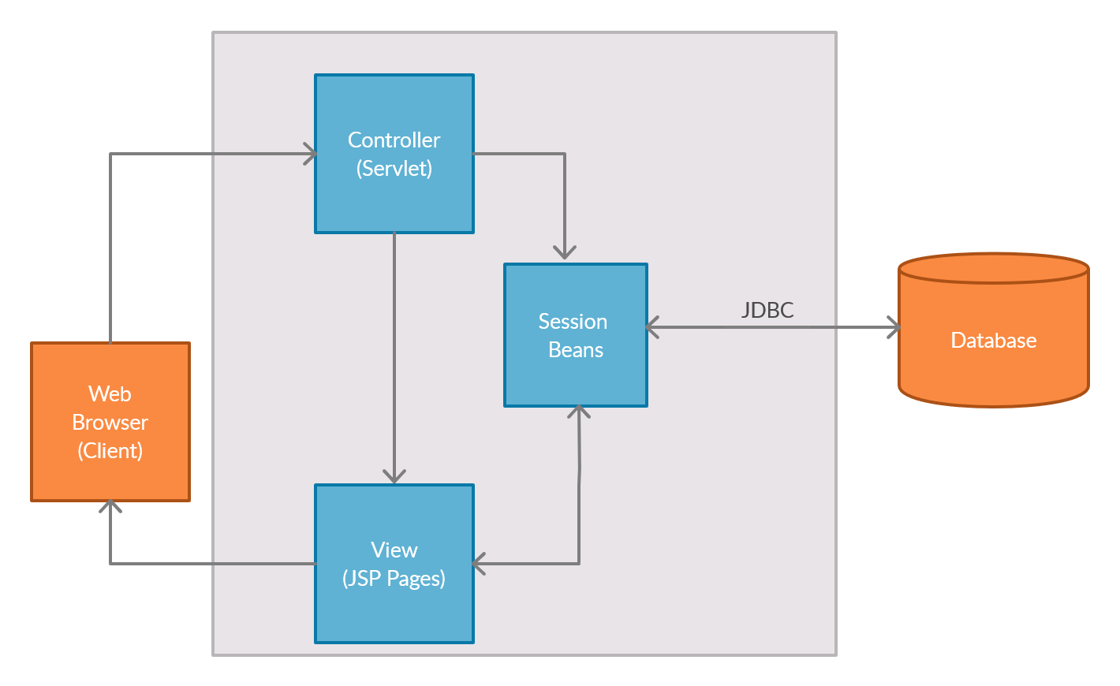

*Fig.3.1-*ARCHITECTURAL BLOCK DIAGRAM

**3.2. Flowchart Diagram**

Fig. 3.2 shows the flow chart of the system. The user first registers on the system and then logins with their respective username and password. If he/she is logged in as a Jobseeker he/she can search for jobs, upload their C.V.s, apply for jobs and also give feedbacks about the system. If he/she is logged in as an Admin then he/she can view all the applicants and their applications and also view jobs registered by various companies. If he/she is logged in as a Job Provider then he/she add and delete jobs and view all the job applications. If the required processes are done they can logout of the system.

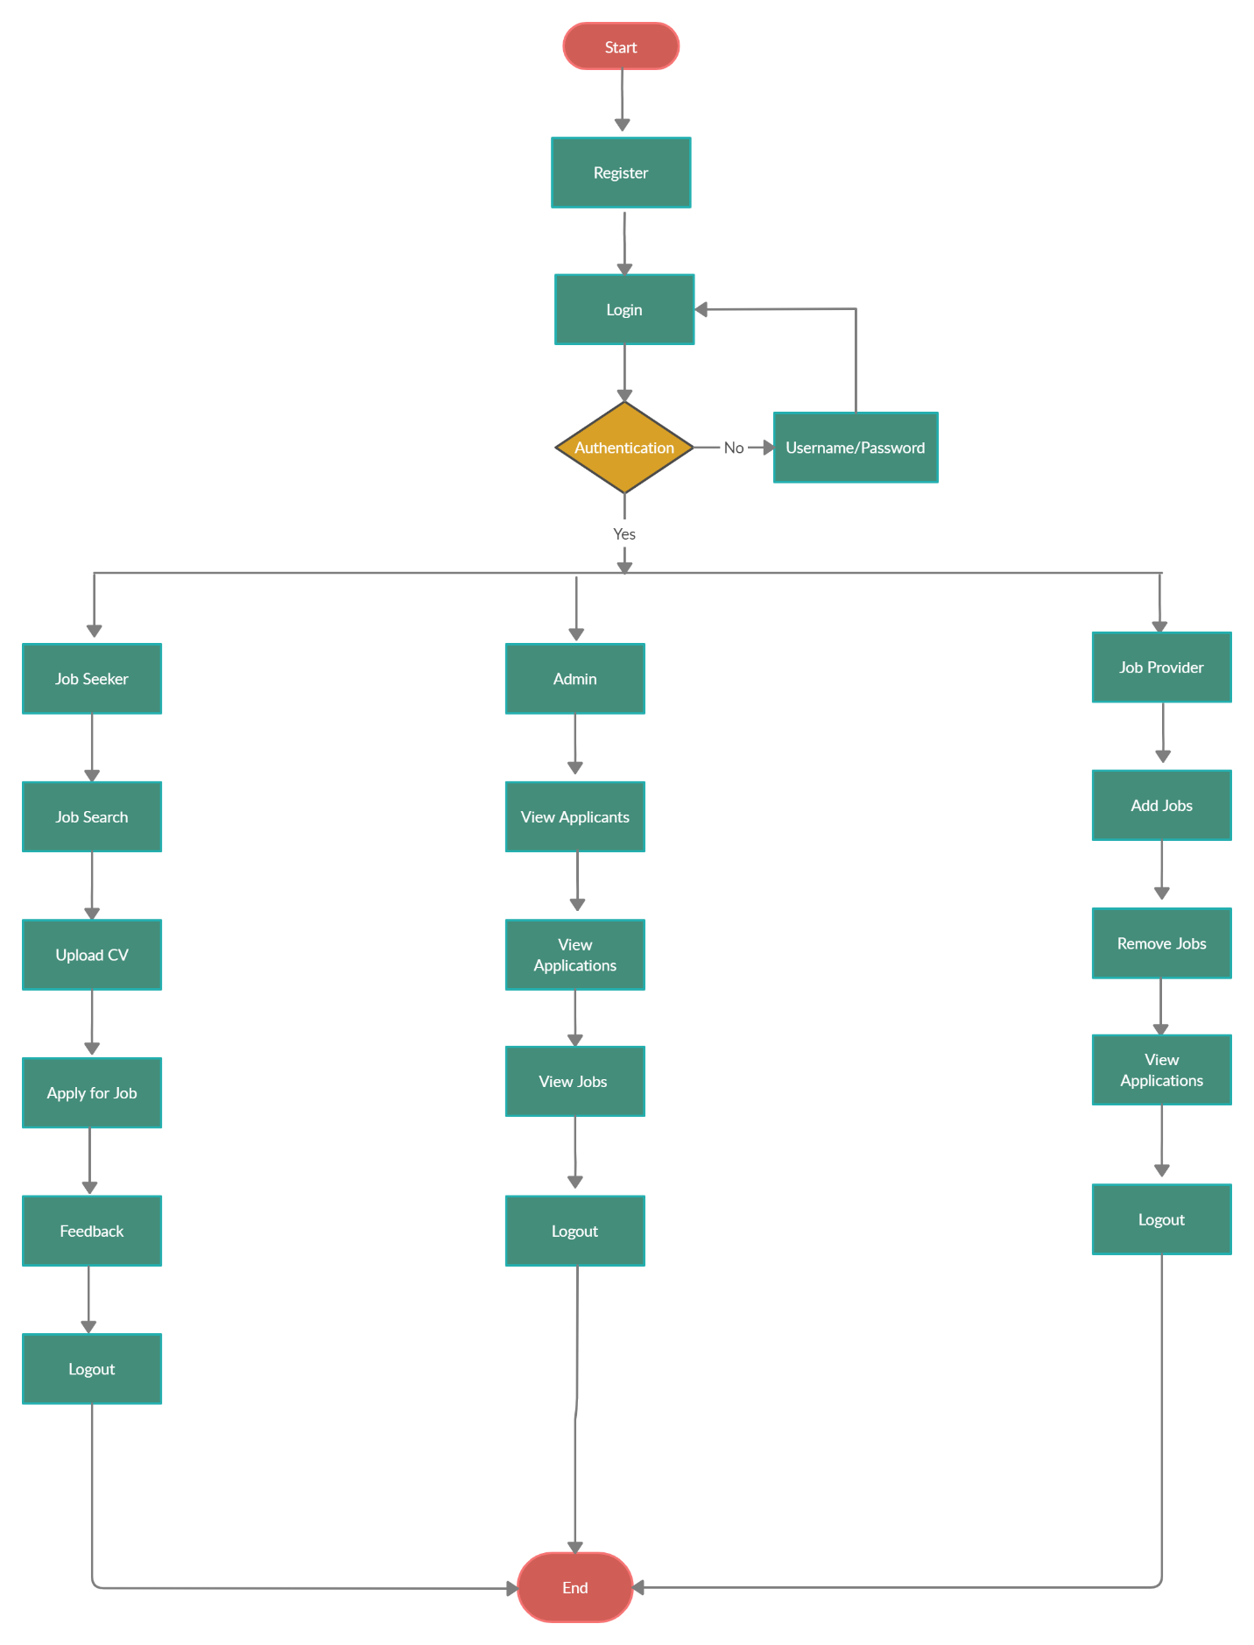

*Fig.3.2*- FLOW CHART

**Chapter 4**

**IMPLEMENTATION DETAILS**

**IMPLEMENTATION DETAILS**

**4.1. System Requirements**

**Hardware Requirements**

* CPU: Intel Core or Xeon 3GHz (or Dual Core 2GHz) or equal AMD CPU
* Cores: Single (Dual/Quad Core is recommended)
* RAM: 4 GB (6 GB recommended)
* Display Resolution: 1280x1024 is recommended, 1024×768 is minimum.

**Software Requirements**

* MySQL Server Version 8.0
* JRE 8 or higher
* JDK 8.0 or higher

**4.2. SOLUTIOIN APPROACH/ METHODOLOGY**

The Online Job Portal is a web-based application which revolutionizes the way companies hire the candidates and job seekers search for job vacancies. Job seekers can give a feedback for the companies so they can improve and make changes accordingly.

The following are the main actors/ users of the system.

* Admin
* Employer
* Job Seeker

**Admin**

The admin user provides various functionalities. The admin has control over the entire portal. It can view the list of candidates registered on the portal, delete candidates with suspicious or inappropriate behaviour and download CVs uploaded by viable candidates.

**Employer**

Employer users will be able to perform functions such as registering with the portal and creating an account by providing details such as Company Name, Company Email, Web Address and Password that are stored in the table in the MySQL database. Once the account is activated this section allows recruiters to post jobs summarizing responsibilities and required skill set that will be stored in the ‘job’ table of MySQL database. The employer will also be given the privilege to add or remove jobs. He/ she can view the list of job openings that are active and delete it when the position gets filled. He/ she can also view applicant details for a particular job posting by downloading their CVs.

**Job Seeker**

Job Seekers will be able to perform functions like registering with the portal and creating an account by providing the details such as First Name, Last Name, Password, Key Skills and Experience that are stored in the ‘employee’ table of the MySQL database. Once the account is activated job seekers get an email of confirmation. Now, they can search, view and apply for jobs as well as update their profile information. Job seekers will also be able to upload their CVs for available job vacancies. All the applied jobs details are stored in the table and updated profile information is stored in the ‘employee’ table of MySQL database. The applicants can also write feedbacks for the companies.

**Chapter 5 -**

**EXPERIMENTAL RESULTS**

**EXPERIMENTAL RESULTS**

**Home Page**

The home page appears in the start of the application. The screen will provide various functionalities like Home, About Us, Company Login, Job Seeker Registration and Contact Us. When clicked on the button, it navigates to the respective screen.

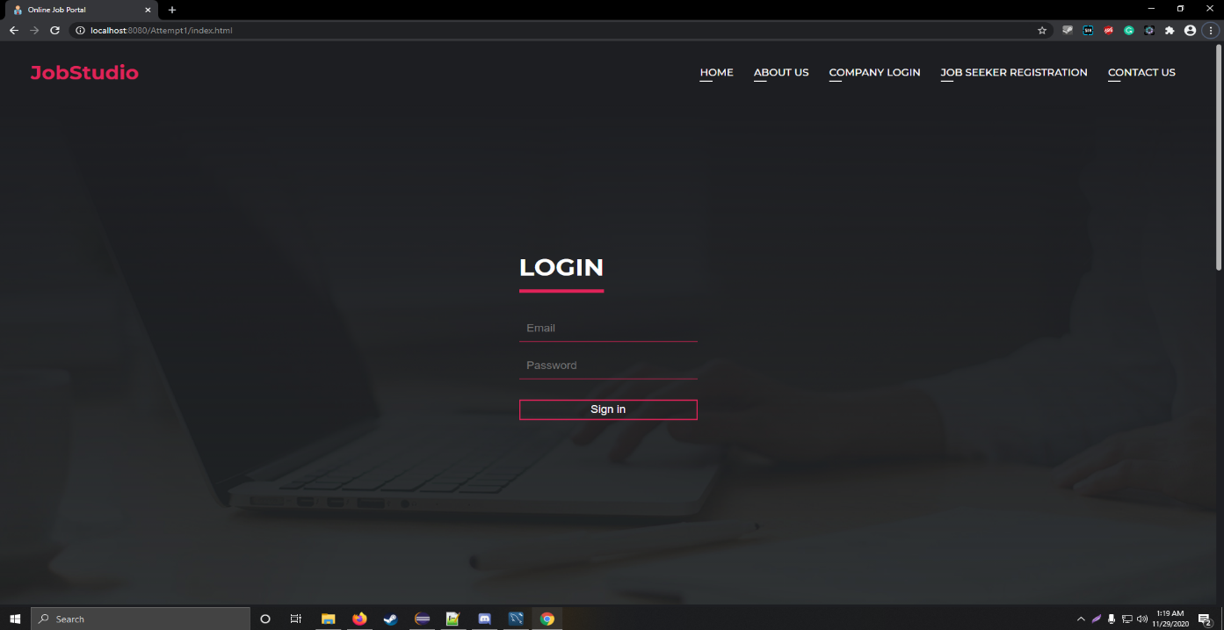

*fig-1*

*Fig.5.1*- Home Page

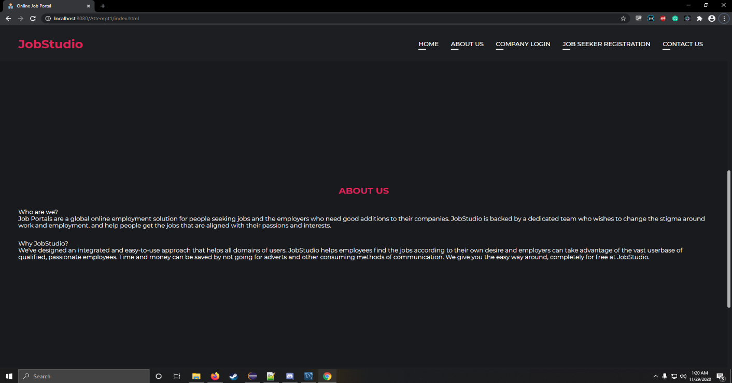

*Fig.5.2*-Home Page

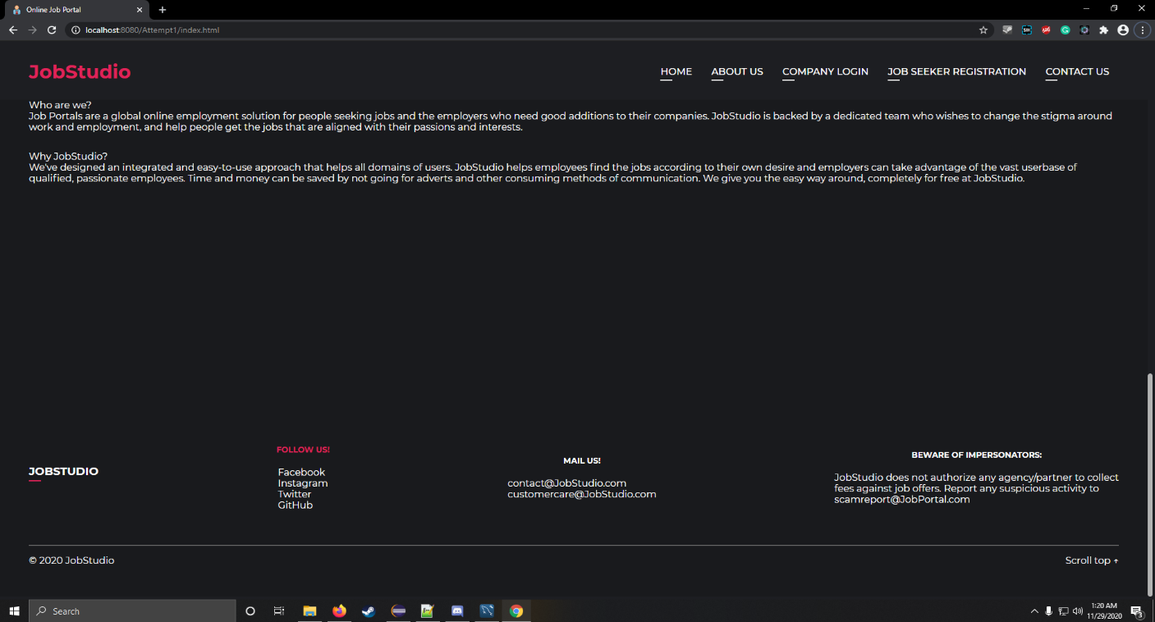

*Fig.5.3*-Home Page

**Admin Page**

After successful login, the admin navigates to the Admin home page where he/ she can view details of the employees registered with the portal.

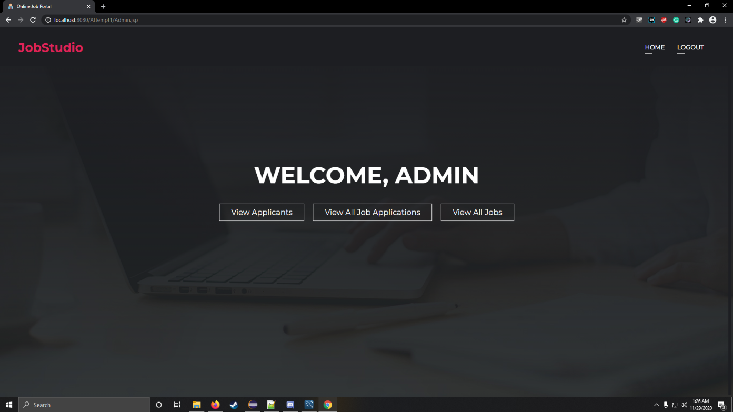

*Fig.5.4*-Admin Page

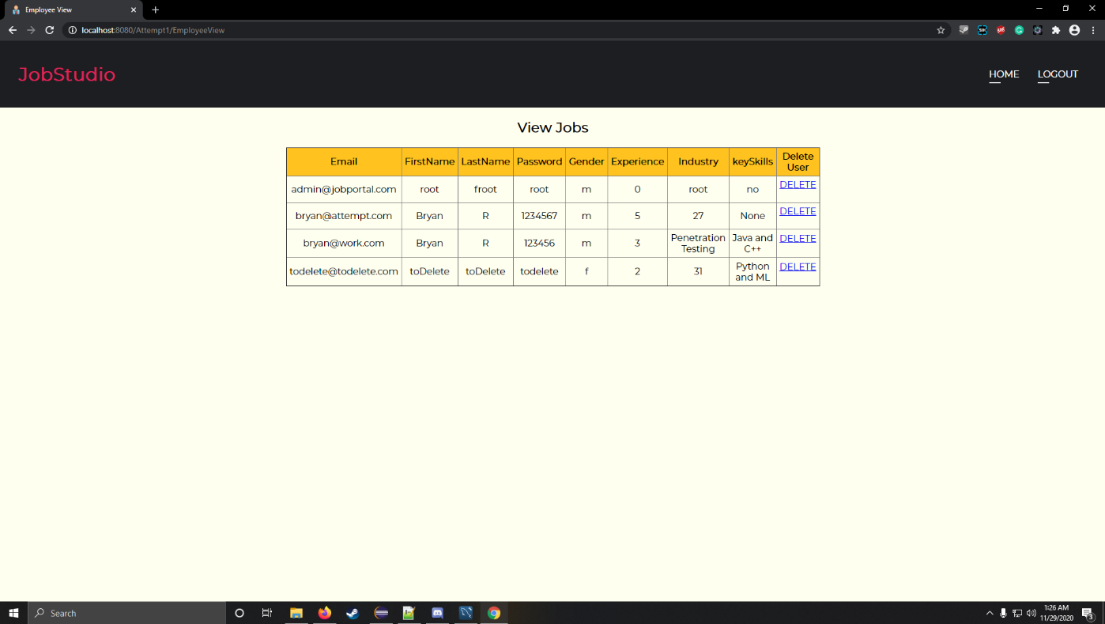

*Fig.5.5*-Admin Page

**Company Login**

Registered employers can login to their accounts from here, if they haven’t registered then they can do so by clicking on ‘Register’.

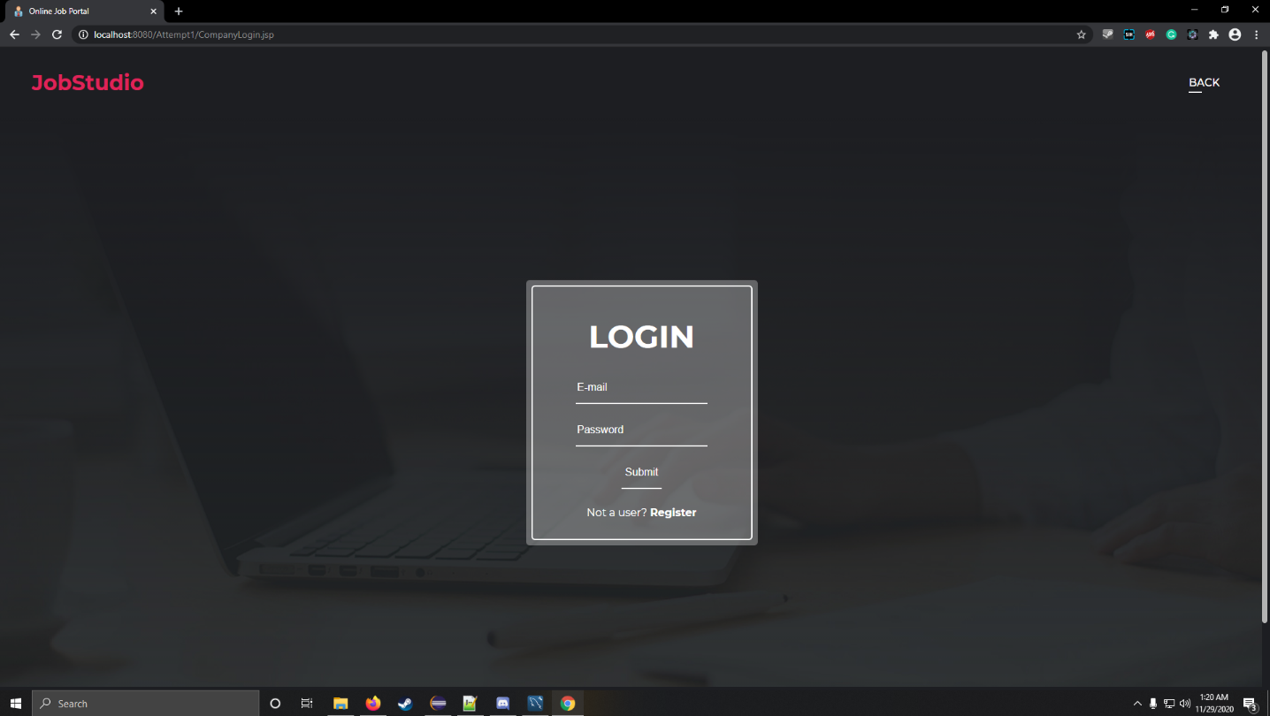

*Fig.5.6*-Company Login

**Company Registration**

After clicking on ‘Register’ new employers can fill out the required details and register with the portal. Once registration is successful, they can login with the help of the login page.

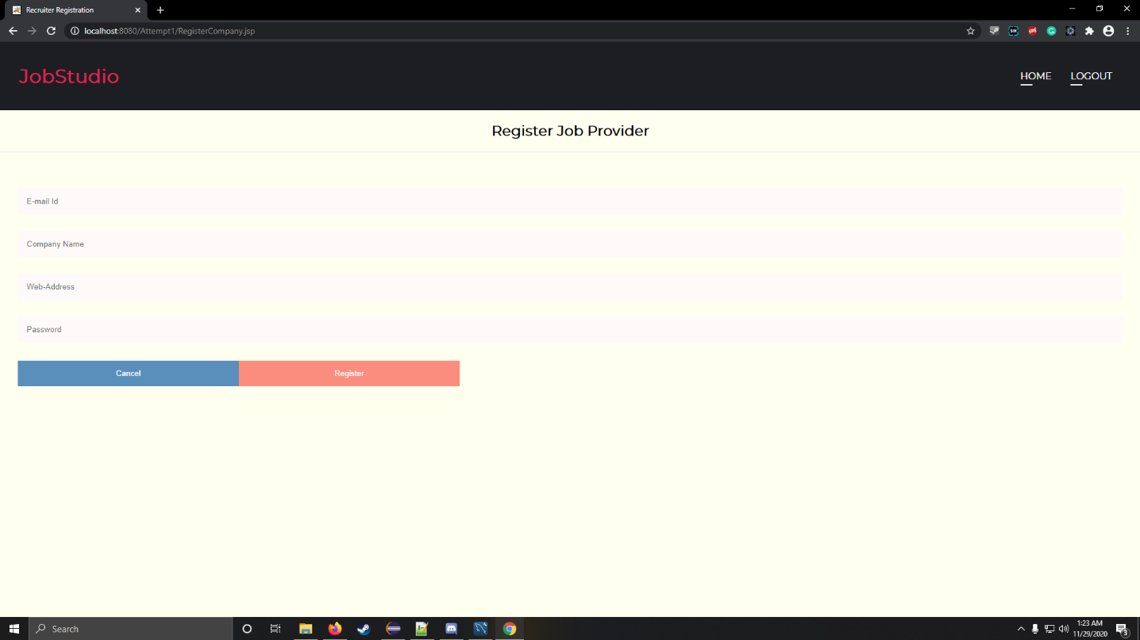

*Fig.5.7*-Company Registration

**Company Home**

When the employer has successfully logged in, this home screen appears. It shows all the functionalities that they can perform such as add/ remove jobs, view applicants and download their CV.

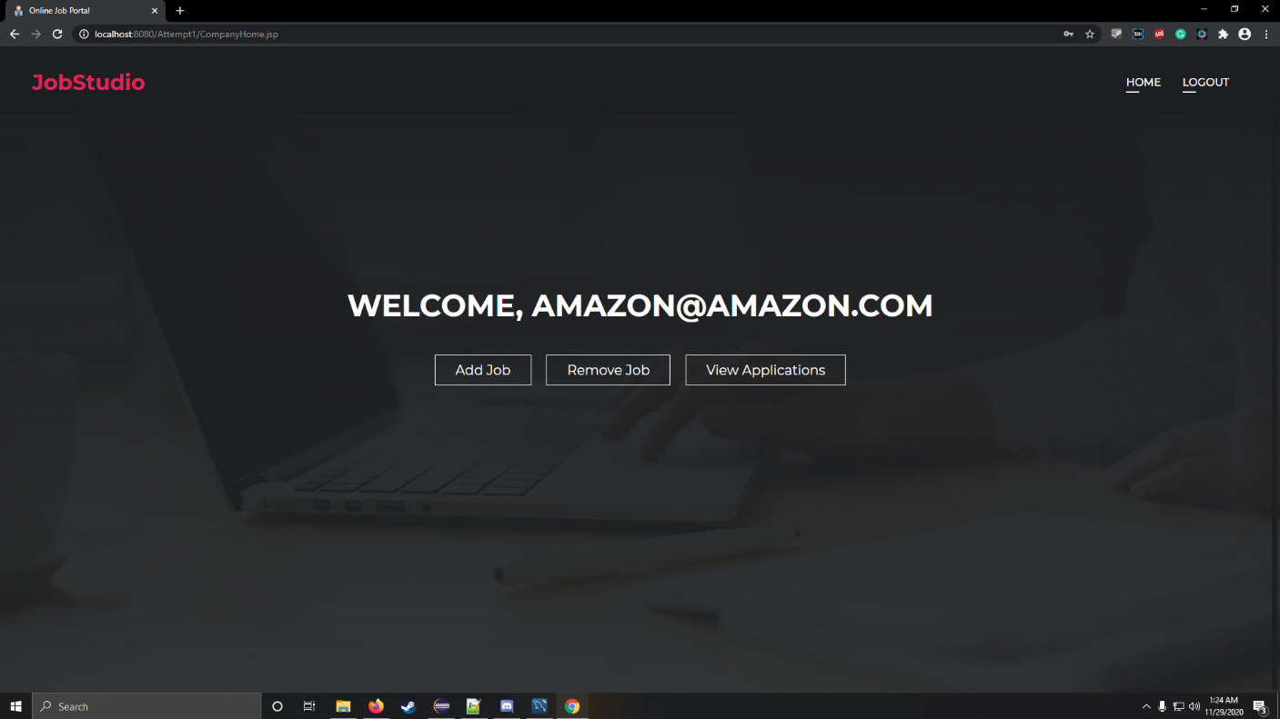

*Fig.5.8*-Company Home

**Add Jobs**

This screen shows a form that the recruiters/ employers need to fill out in order to add an available job vacancy.

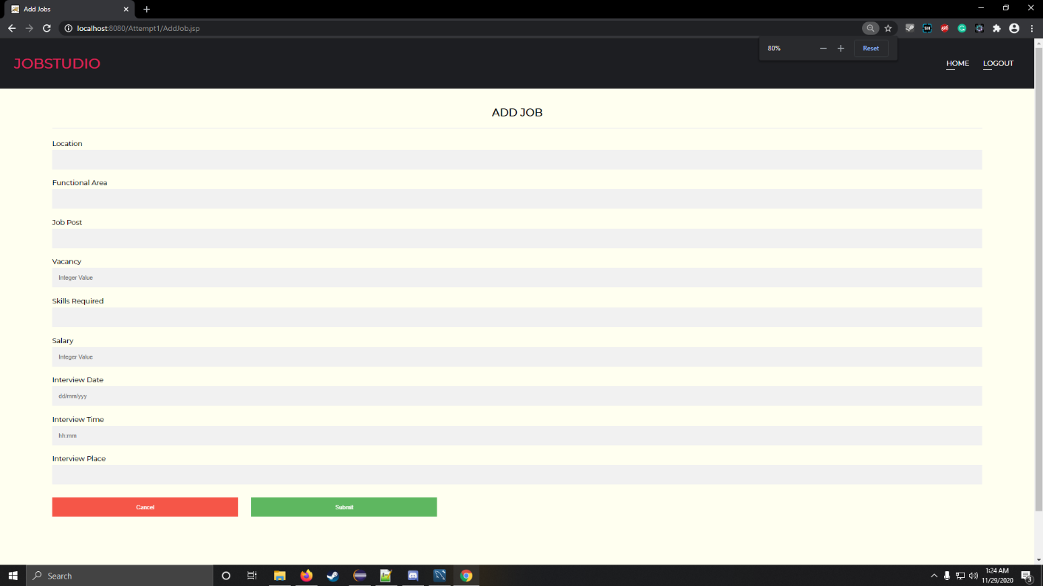

*Fig.5.9*- Add Jobs

**Remove Job**

The list of added job postings can be viewed from this screen. Employers can easily delete the jobs if the position is no longer available.

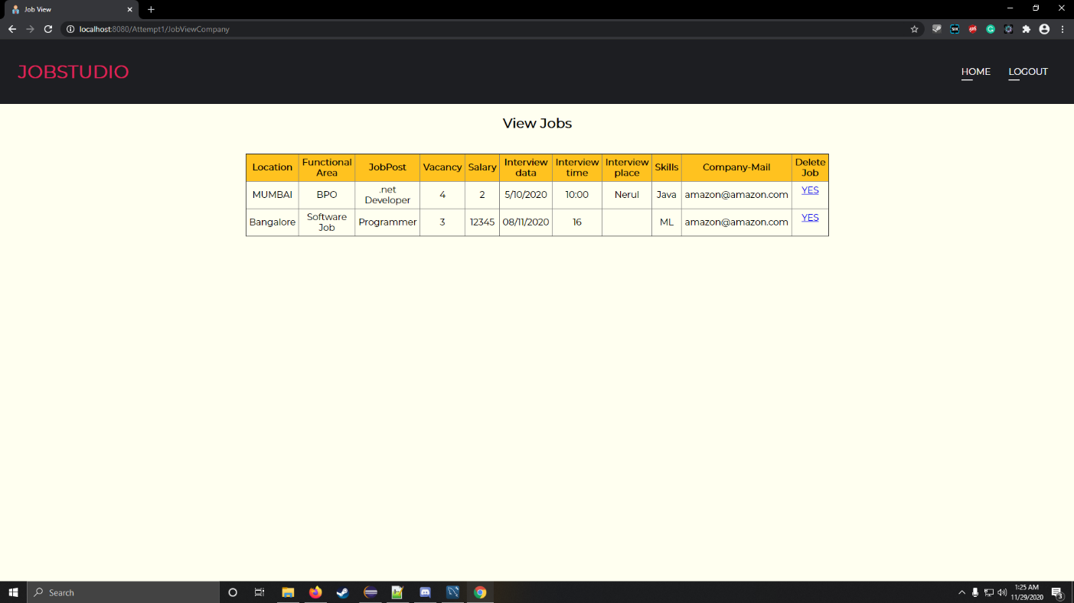

*Fig.5.10*-Remove Jobs

**View Applications**

From this screen employers can view the list of applicants who have applied for the job. They can approve candidates for an interview and view their details by downloading their CV.

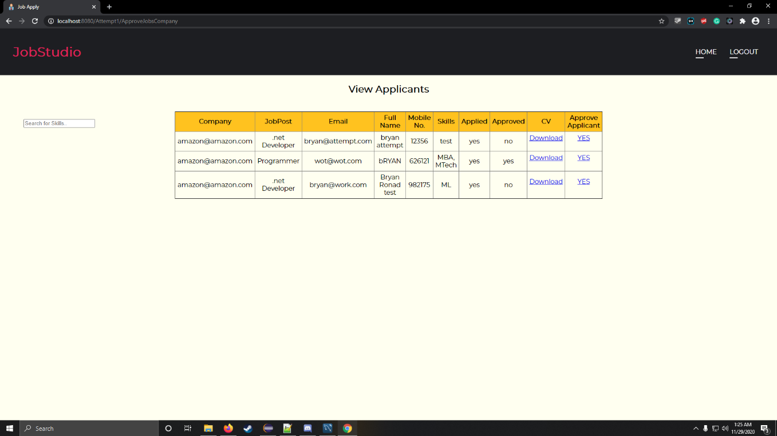

*Fig.5.11*-View Applications

**Seeker Home**

Job Seekers can login from the same place as the admin. Once login is successful for registered users the screen below shows all the functionalities available to them. Candidates can register by clicking on ‘Job Seeker Registration’.

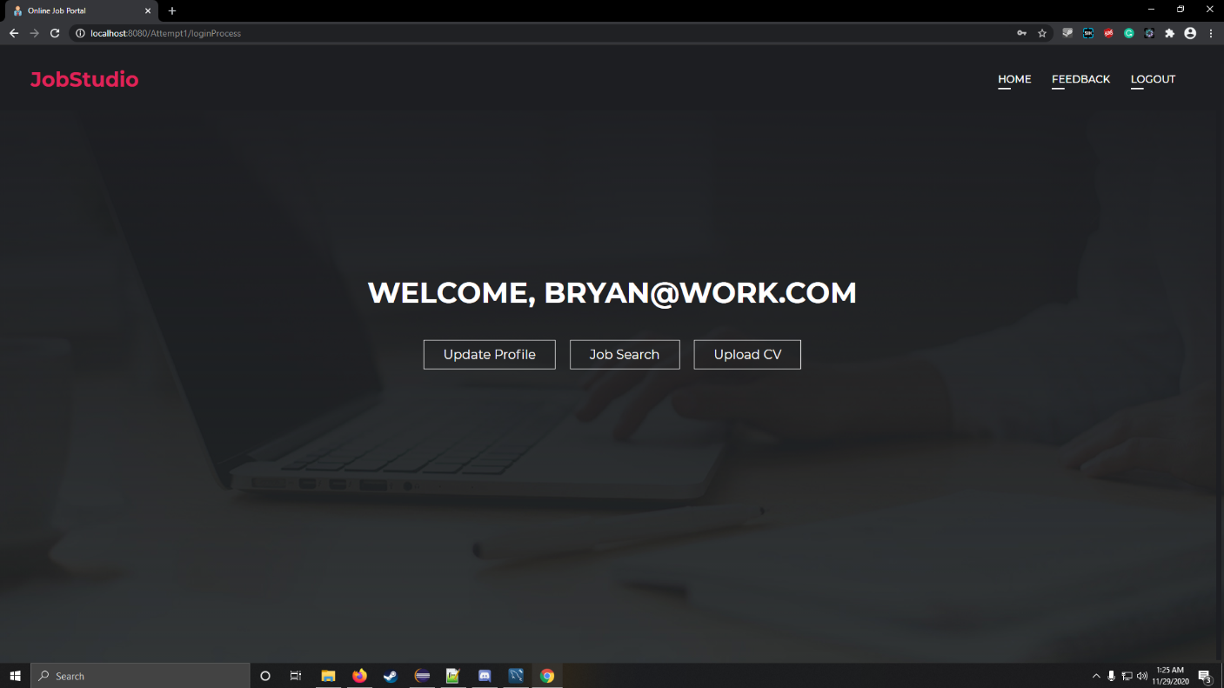

*Fig.5.12*- Seeker Home

**Seeker Registration**

New users can register by filling out the form visible on the screen. After registration is successful, they can login easily.

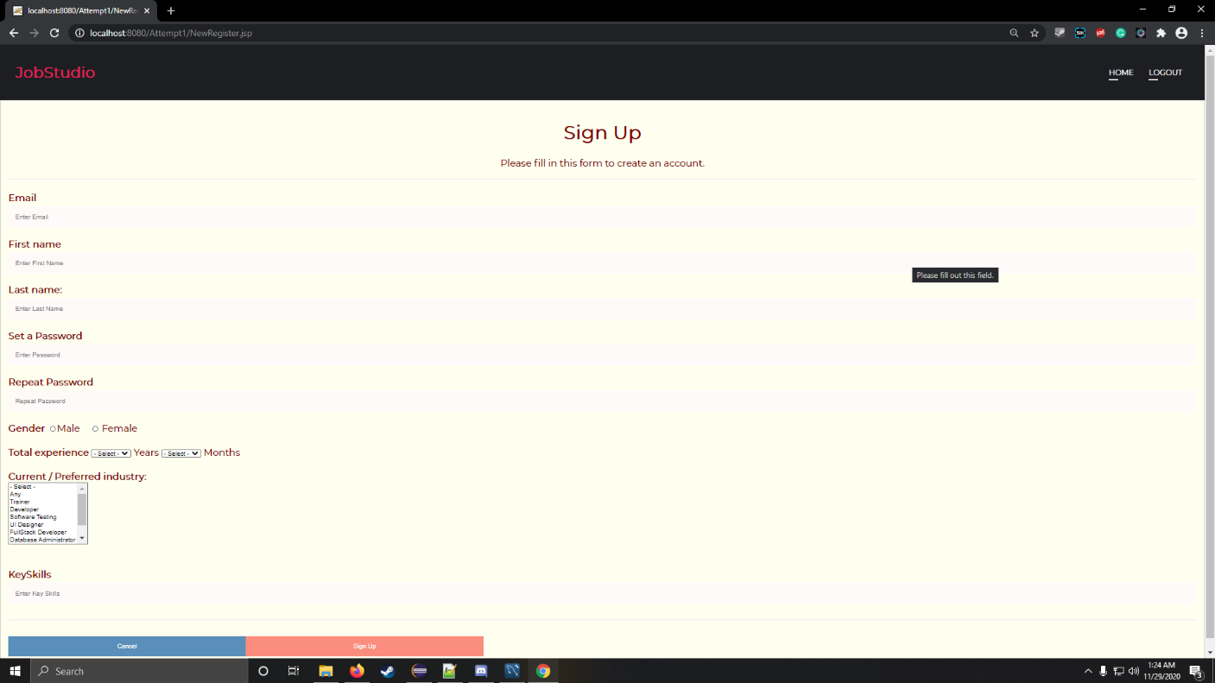

*Fig.5.13*-Seeker Registration

**Job Search**

Registered candidates can browse through a wide range of available job postings and find the right one conveniently.

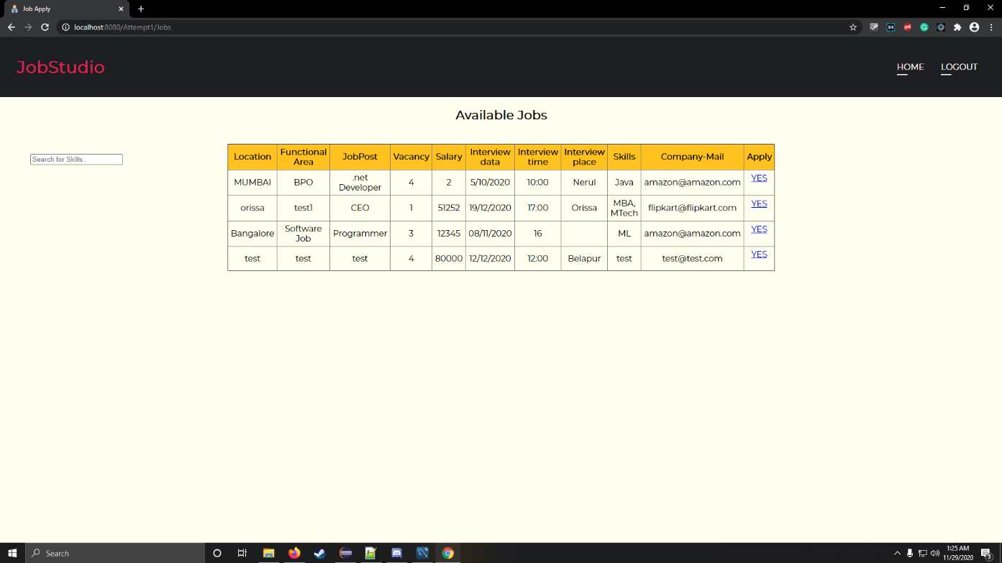

*Fig.5.14*-Job Search

**Upload CV**

Candidates can simply apply for any desired job vacancy by easily uploading their CV.

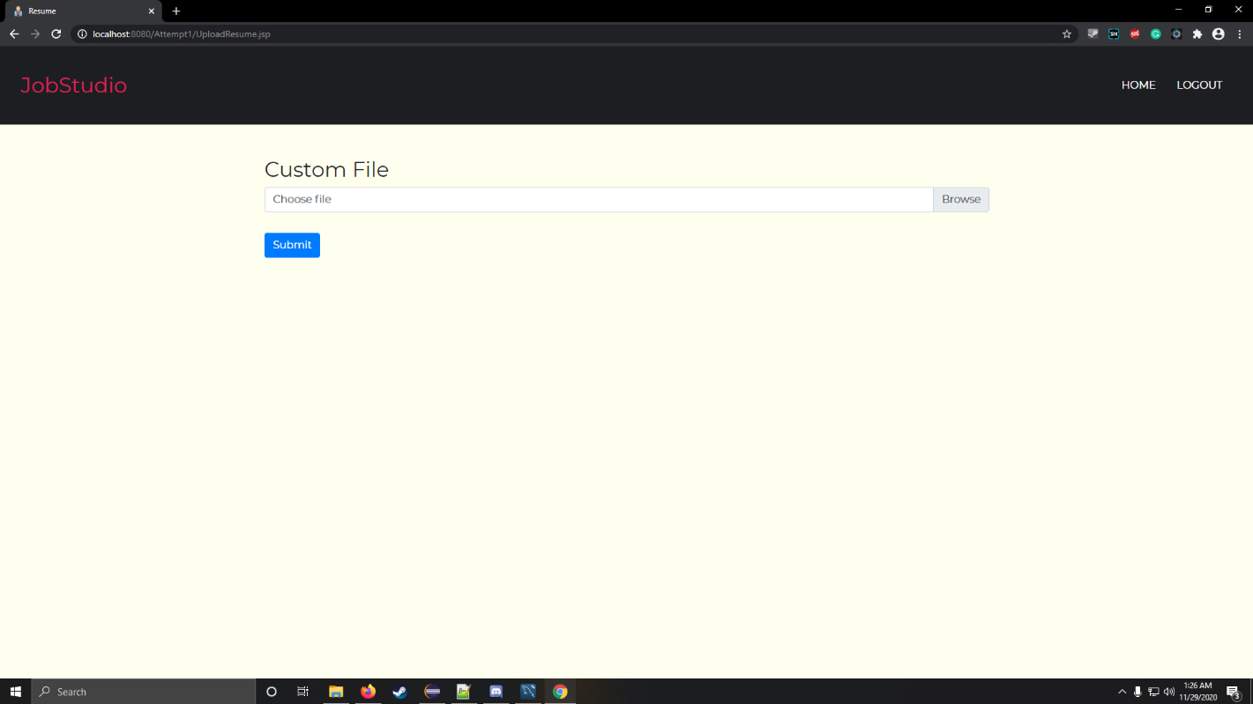

*Fig.5.15* Upload C.V.

**Update Profile**

Seekers can also update their profile information with ease.

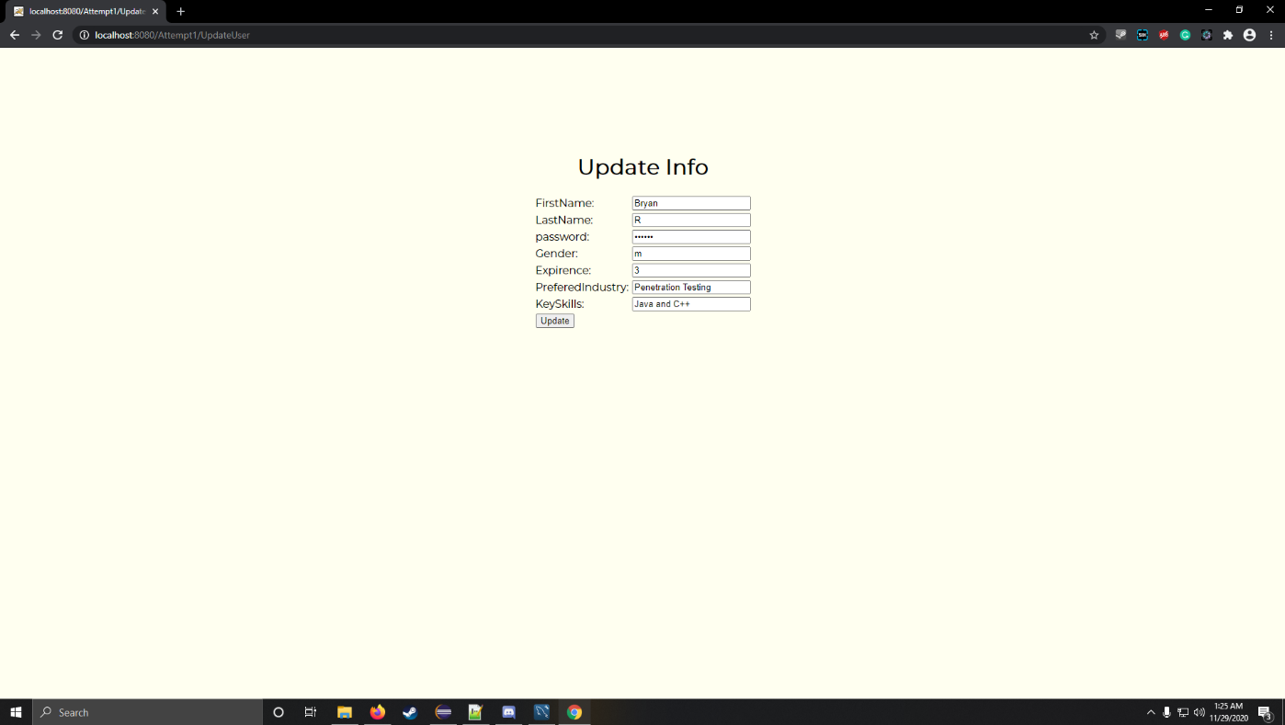

*Fig.5.16*-Update Profile

**Feedback**

Applicants can also give their valuable feedback on the companies; this can be beneficial for other applicants as well as the companies. Companies can make improve and make necessary changes after reading the feedback.

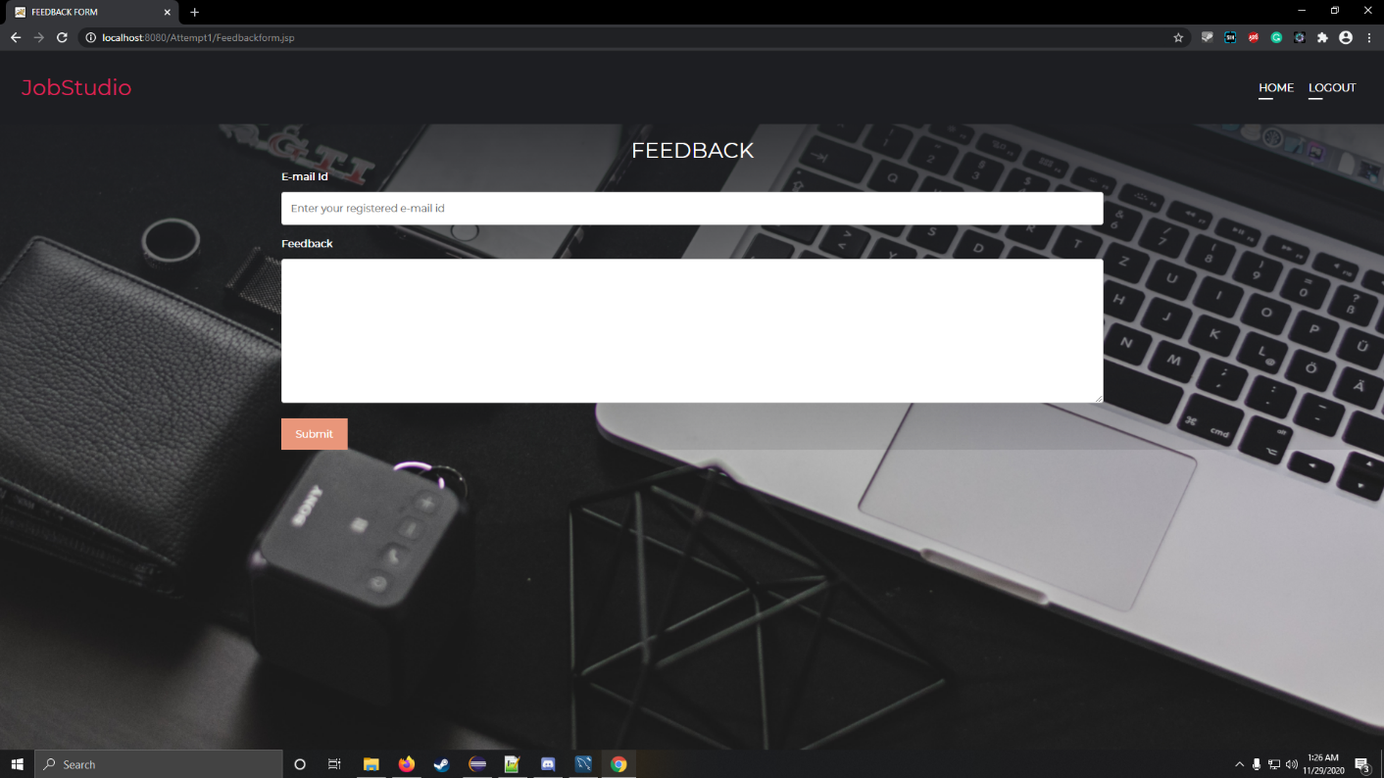

*Fig.5.17*-Feedback

**Chapter 6 -**

**CONCLUSION AND FUTURE SCOPE**

**CONCLUSION AND FUTURE SCOPE**

**6.1. Conclusion**

Online Job Portals are a revolutionizing element in the sphere of recruitment. They act as a communication bridge between applicants and recruiters facilitating their requirements. This application helps organizations to have a greater exposure to the candidate pool and job seekers can choose from a wide range of jobs matching their interests. This portal provides an enhanced user experience for job seekers as well recruiters.

The application has achieved all the requirements that were initially set in the requirements gathering stage. Starting from requirements elicitation to design, construction, implementation and testing we have gained a very good experience working with various technologies at every phase.

**6.2 Future Scope**

This project fulfils the primary requirements of job seekers and employers. It can be extended in several ways – The system can provide recommendations and email updates based on the candidate’s search history. For the employers, a small quiz can be conducted based on logical skills to help them sieve through candidates quickly.

**References-**

[1] Dorn J., Naz T. (2007) Integration of Job Portals by Meta-search. In: Gonçalves R.J., Müller J.P., Mertins K., Zelm M. (eds) Enterprise Interoperability II. Springer, London. <https://doi.org/10.1007/978-1-84628-858-6_44>.

[2] <https://www.peoplematters.in/article/talent-acquisition/e-recruitment-a-futuristic-cost-reduction-process-4355>

[3] <https://www.tutorialspoint.com/index.htm>

[4] <https://www.w3schools.com/>

[5] <https://www.thebalancecareers.com/top-best-job-websites-2064080>

[6] <https://timesnext.com/top-5-job-sites-in-india/>

**Java Servlet codes:**

AddJob.java

package credentials**;**

**import** java**.**io**.**IOException**;**

**import** java**.**io**.**PrintWriter**;**

**import** javax**.**servlet**.**ServletException**;**

**import** javax**.**servlet**.**http**.**HttpServlet**;**

**import** javax**.**servlet**.**http**.**HttpServletRequest**;**

**import** javax**.**servlet**.**http**.**HttpServletResponse**;**

**import** javax**.**servlet**.**http**.**HttpSession**;**

**import** credentials**.**dao**.**AddJobDao**;**

public class AddJob **extends** HttpServlet **{**

public AddJob**()** **{**

**super();**

**}**

protected void doGet**(**HttpServletRequest request**,** HttpServletResponse response**)**

**throws** ServletException**,** IOException **{**

AddJobDao dao **=** **new** AddJobDao**();**

PrintWriter p **=** response**.**getWriter**();**

String s1 **=** request**.**getParameter**(**"location"**);**

String s2 **=** request**.**getParameter**(**"area"**);**

String s3 **=** request**.**getParameter**(**"post"**);**

String s4 **=** request**.**getParameter**(**"vacancy"**);**

String s5 **=** request**.**getParameter**(**"salary"**);**

String s6 **=** request**.**getParameter**(**"ivdate"**);**

String s7 **=** request**.**getParameter**(**"ivtime"**);**

String s8 **=** request**.**getParameter**(**"ivplace"**);**

String s9 **=** request**.**getParameter**(**"skill"**);**

HttpSession session **=** request**.**getSession**(false);**

String s10 **=** **(**String**)** session**.**getAttribute**(**"username"**);**

System**.**out**.**println**(**s10**);**

System**.**out**.**println**(**s1 **+** "" **+** s2 **+** "" **+** s3 **+** "" **+** s4 **+** "" **+** s5 **+** "" **+** s6 **+** "" **+** s7 **+** "" **+** s8 **+** "" **+** s9**);**

**if** **(**s1 **!=** **null** **&&** s2 **!=** **null** **&&** s3 **!=** **null** **&&** s4 **!=** **null** **&&** s5 **!=** **null** **&&** s6 **!=** **null** **&&** s7 **!=** **null** **&&** s8 **!=** **null**

**&&** s9 **!=** **null** **&&** s10 **!=** **null)** **{**

System**.**out**.**println**(**"Dao.update called"**);**

**if** **(**dao**.**update**(**s1**,** s2**,** s3**,** s4**,** s5**,** s6**,** s7**,** s8**,** s9**,** s10**)** **==** 1**)** **{**

p**.**println**(**"<script>alert('Job Added Successfully')</script>"**);**

response**.**setHeader**(**"Refresh"**,** "1;CompanyHome.jsp"**);**

**}** **else** **{**

p**.**println**(**"<script>alert('Job Adding Failed')</script>"**);**

response**.**setHeader**(**"Refresh"**,** "1;CompanyHome.jsp"**);**

**}**

**}**

**}**

protected void doPost**(**HttpServletRequest request**,** HttpServletResponse response**)**

**throws** ServletException**,** IOException **{**

doGet**(**request**,** response**);**

**}**

**}**

AppliedJob.java

package jobUtil**;**

**import** java**.**io**.**IOException**;**

**import** java**.**sql**.**SQLException**;**

**import** javax**.**servlet**.**ServletException**;**

**import** javax**.**servlet**.**annotation**.**WebServlet**;**

**import** javax**.**servlet**.**http**.**HttpServlet**;**

**import** javax**.**servlet**.**http**.**HttpServletRequest**;**

**import** javax**.**servlet**.**http**.**HttpServletResponse**;**

**import** jobBean**.**Job**;**

**import** jobBean**.**dao**.**JobDao**;**

public class AppliedJob **extends** HttpServlet **{**

private static final long serialVersionUID **=** 1L**;**

protected void doGet**(**HttpServletRequest request**,** HttpServletResponse response**)** **throws** ServletException**,** IOException **{**

String Jpost**=**request**.**getParameter**(**"id"**);**

String Company**=**request**.**getParameter**(**"comp"**);**

System**.**out**.**println**(**"id"**+**Jpost**);**

System**.**out**.**println**(**"cmail"**+**Company**);**

**try** **{**Job Ajobs **=**JobDao**.**applylist**(**Jpost**,** Company**);**

request**.**setAttribute**(**"ApplyJobList"**,**Ajobs**);**

request**.**getRequestDispatcher**(**"Apply.jsp"**).**forward**(**request**,** response**);**

**}**

**catch** **(**SQLException e**)** **{**System**.**out**.**println**(**e**);}**

**}**

protected void doPost**(**HttpServletRequest request**,** HttpServletResponse response**)** **throws** ServletException**,** IOException **{**doGet**(**request**,** response**);}**

**}**

ApproveJobs.java

package jobUtil**;**

**import** java**.**io**.**IOException**;**

**import** java**.**util**.**List**;**

**import** javax**.**servlet**.**ServletException**;**

**import** javax**.**servlet**.**http**.**HttpServlet**;**

**import** javax**.**servlet**.**http**.**HttpServletRequest**;**

**import** javax**.**servlet**.**http**.**HttpServletResponse**;**

**import** jobBean**.**TotalApplication**;**

**import** jobBean**.**dao**.**JobDao**;**

public class ApproveJobs **extends** HttpServlet **{**

private static final long serialVersionUID **=** 1L**;**

protected void doGet**(**HttpServletRequest request**,** HttpServletResponse response**)** **throws** ServletException**,** IOException **{**

response**.**setContentType**(**"text/html"**);**

List**<**TotalApplication**>** TotalJ **=**JobDao**.**appliedJobs**();**

request**.**setAttribute**(**"TotalJobs"**,**TotalJ**);**

request**.**getRequestDispatcher**(**"AppliedJobs.jsp"**).**forward**(**request**,** response**);**

**}**

protected void doPost**(**HttpServletRequest request**,** HttpServletResponse response**)** **throws** ServletException**,** IOException **{**

doGet**(**request**,** response**);**

**}**

**}**

ApproveJobsCompany.java

package jobUtil**;**

**import** java**.**io**.**IOException**;**

**import** java**.**util**.**List**;**

**import** javax**.**servlet**.**ServletException**;**

**import** javax**.**servlet**.**http**.**HttpServlet**;**

**import** javax**.**servlet**.**http**.**HttpServletRequest**;**

**import** javax**.**servlet**.**http**.**HttpServletResponse**;**

**import** javax**.**servlet**.**http**.**HttpSession**;**

**import** jobBean**.**TotalApplication**;**

**import** jobBean**.**dao**.**JobDao**;**

public class ApproveJobsCompany **extends** HttpServlet **{**

private static final long serialVersionUID **=** 1L**;**

protected void doGet**(**HttpServletRequest request**,** HttpServletResponse response**)** **throws** ServletException**,** IOException **{**

response**.**setContentType**(**"text/html"**);**

HttpSession session **=** request**.**getSession**(false);**

String cname **=** **(**String**)** session**.**getAttribute**(**"username"**);**

System**.**out**.**println**(**cname**);**

List**<**TotalApplication**>** TotalJ **=**JobDao**.**appliedJobsCompany**(**cname**);**

request**.**setAttribute**(**"TotalJobs"**,**TotalJ**);**

request**.**getRequestDispatcher**(**"AppliedJobs.jsp"**).**forward**(**request**,** response**);**

**}**

protected void doPost**(**HttpServletRequest request**,** HttpServletResponse response**)** **throws** ServletException**,** IOException **{**

doGet**(**request**,** response**);**

**}**

**}**

CompanyLogin.java

package credentials**;**

**import** java**.**io**.**IOException**;**

**import** java**.**io**.**PrintWriter**;**

**import** javax**.**servlet**.**ServletException**;**

**import** javax**.**servlet**.**http**.**HttpServlet**;**

**import** javax**.**servlet**.**http**.**HttpServletRequest**;**

**import** javax**.**servlet**.**http**.**HttpServletResponse**;**

**import** javax**.**servlet**.**http**.**HttpSession**;**

**import** credentials**.**dao**.**CompanyLoginDao**;**

public class CompanyLogin **extends** HttpServlet **{**

public CompanyLogin**()** **{**

**super();**

**}**

protected void doGet**(**HttpServletRequest request**,** HttpServletResponse response**)** **throws** ServletException**,** IOException **{**

PrintWriter p **=** response**.**getWriter**();**

response**.**setContentType**(**"text/html"**);**

String s1**=**request**.**getParameter**(**"mail"**);**

String s2**=**request**.**getParameter**(**"pwd"**);**

HttpSession session **=** request**.**getSession**(false);**

session**.**setAttribute**(**"username"**,** s1**);**

CompanyLoginDao dao**=new** CompanyLoginDao**();**

session**.**setAttribute**(**"status"**,** **false);**

**if(**dao**.**validate**(**s1**,** s2**)){**response**.**sendRedirect**(**"CompanyHome.jsp"**);}**

**else{**

p**.**println**(**"<script>alert('Company does not exist')</script>"**);**

response**.**setHeader**(**"Refresh"**,**"1;CompanyLogin.jsp"**);}**

**}**

protected void doPost**(**HttpServletRequest request**,** HttpServletResponse response**)** **throws** ServletException**,** IOException **{**

doGet**(**request**,** response**);**

**}**

**}**

DeleteJob.java

package jobUtil**;**

**import** java**.**io**.**IOException**;**

**import** java**.**io**.**PrintWriter**;**

**import** javax**.**servlet**.**ServletException**;**

**import** javax**.**servlet**.**http**.**HttpServlet**;**

**import** javax**.**servlet**.**http**.**HttpServletRequest**;**

**import** javax**.**servlet**.**http**.**HttpServletResponse**;**

**import** javax**.**servlet**.**http**.**HttpSession**;**

**import** jobBean**.**dao**.**JobDao**;**

public class DeleteJob **extends** HttpServlet **{**

private static final long serialVersionUID **=** 1L**;**

protected void doGet**(**HttpServletRequest request**,** HttpServletResponse response**)** **throws** ServletException**,** IOException **{**

String Jpost**=**request**.**getParameter**(**"post"**);**

String Company**=**request**.**getParameter**(**"comp"**);**

HttpSession session **=** request**.**getSession**(false);**

String user **=** **(**String**)** session**.**getAttribute**(**"username"**);**

System**.**out**.**println**(**Jpost**);**

System**.**out**.**println**(**Company**);**

PrintWriter p **=** response**.**getWriter**();**

JobDao d**=new** JobDao**();**

**if(**d**.**deleteJob**(**Jpost**,** Company**)==**1**)** **{**

p**.**println**(**"<script>alert('Job Deleted Successfully')</script>"**);**

**if(**user**==**"admin@admin.com"**)**

response**.**setHeader**(**"Refresh"**,** "1;Admin.jsp"**);**

**else**

response**.**setHeader**(**"Refresh"**,** "1;CompanyHome.jsp"**);**

**}**

**else**

**{**

p**.**println**(**"<script>alert('Deletion failed')</script>"**);**

response**.**setHeader**(**"Refresh"**,** "1;JobViewCompany.jsp"**);**

**}**

**}**

protected void doPost**(**HttpServletRequest request**,** HttpServletResponse response**)** **throws** ServletException**,** IOException **{**doGet**(**request**,** response**);}**

**}**

DeleteUser.java

package employeeUtil**;**

**import** java**.**io**.**IOException**;**

**import** java**.**io**.**PrintWriter**;**

**import** javax**.**servlet**.**ServletException**;**

**import** javax**.**servlet**.**http**.**HttpServlet**;**

**import** javax**.**servlet**.**http**.**HttpServletRequest**;**

**import** javax**.**servlet**.**http**.**HttpServletResponse**;**

**import** credentials**.**dao**.**EmployeeDao**;**

public class DeleteUser **extends** HttpServlet **{**

private static final long serialVersionUID **=** 1L**;**

protected void doGet**(**HttpServletRequest request**,** HttpServletResponse response**)** **throws** ServletException**,** IOException **{**

String email **=** request**.**getParameter**(**"email"**);**

System**.**out**.**println**(**email **+** "deleted"**);**

PrintWriter p **=** response**.**getWriter**();**

EmployeeDao e **=** **new** EmployeeDao**();**

**if(**e**.**deleteUser**(**email**)==**1**)** **{**

p**.**println**(**"<script>alert('User Deleted Successfully')</script>"**);**

response**.**setHeader**(**"Refresh"**,** "1;Admin.jsp"**);**

**}**

**else**

**{**

p**.**println**(**"<script>alert('Deletion Failed')</script>"**);**

response**.**setHeader**(**"Refresh"**,** "1;EmployeeView.jsp"**);**

**}**

**}**

protected void doPost**(**HttpServletRequest request**,** HttpServletResponse response**)** **throws** ServletException**,** IOException **{**doGet**(**request**,** response**);}**

**}**

DownloadCV.java

package credentials**;**

**import** java**.**io**.**IOException**;**

**import** java**.**io**.**InputStream**;**

**import** javax**.**servlet**.**ServletException**;**

**import** javax**.**servlet**.**http**.**HttpServlet**;**

**import** javax**.**servlet**.**http**.**HttpServletRequest**;**

**import** javax**.**servlet**.**http**.**HttpServletResponse**;**

**import** java**.**sql**.**Blob**;**

**import** java**.**sql**.**SQLException**;**

**import** credentials**.**dao**.**EmployeeDao**;**

public class DownloadCV **extends** HttpServlet **{**

private static final long serialVersionUID **=** 1L**;**

protected void doGet**(**HttpServletRequest request**,** HttpServletResponse response**)** **throws** ServletException**,** IOException **{**

String email**=**request**.**getParameter**(**"user"**);**

System**.**out**.**println**(**email**);**

EmployeeDao e **=** **new** EmployeeDao**();**

**try** **{**

Blob fileData **=** e**.**downloadCV**(**email**);**

String contentType **=** getServletContext**().**getMimeType**(**"filename"**);**

**if** **(**contentType **==** **null)** **{**

contentType **=** "application/octet-stream"**;**

**}**

System**.**out**.**println**(**"Content Type: " **+** contentType**);**

response**.**setContentType**(**"APPLICATION/OCTET-STREAM"**);**

response**.**setHeader**(**"Content-Type"**,** contentType**);**

response**.**setHeader**(**"Content-Length"**,** String**.**valueOf**(**fileData**.**length**()));**

response**.**setHeader**(**"Content-Disposition"**,** "inline; filename=\"" **+**" cv.pdf"**+** "\""**);**

System**.**out**.**println**(**fileData**);**

**if(**fileData**!=null)** **{**

InputStream is **=** fileData**.**getBinaryStream**();**

byte**[]** bytes **=** **new** byte**[**1024**];**

int bytesRead**;**

**while** **((**bytesRead **=** is**.**read**(**bytes**))** **!=** **-**1**)** **{**

// Write image data to Response.

response**.**getOutputStream**().**write**(**bytes**,** 0**,** bytesRead**);**

**}**

is**.**close**();**

**}**

**}**

**catch(**SQLException ex**)** **{** System**.**out**.**println**(**ex**);}**

**}**

protected void doPost**(**HttpServletRequest request**,** HttpServletResponse response**)** **throws** ServletException**,** IOException **{**

doGet**(**request**,** response**);**

**}**

**}**

EmployeeView.java

package employeeUtil**;**

**import** java**.**io**.**IOException**;**

**import** java**.**sql**.**SQLException**;**

**import** java**.**util**.**List**;**

**import** javax**.**servlet**.**ServletException**;**

**import** javax**.**servlet**.**http**.**HttpServlet**;**

**import** javax**.**servlet**.**http**.**HttpServletRequest**;**

**import** javax**.**servlet**.**http**.**HttpServletResponse**;**

**import** employeeBean**.**Employee**;**

**import** credentials**.**dao**.**EmployeeDao**;**

public class EmployeeView **extends** HttpServlet **{**

private static final long serialVersionUID **=** 1L**;**

protected void doGet**(**HttpServletRequest request**,** HttpServletResponse response**)** **throws** ServletException**,** IOException **{**

response**.**setContentType**(**"text/html"**);**

**try** **{**List**<**Employee**>** employee **=** EmployeeDao**.**list**();**

request**.**setAttribute**(**"EmployeeViewList"**,**employee**);**

request**.**getRequestDispatcher**(**"EmployeeView.jsp"**).**forward**(**request**,** response**);**

**}** **catch** **(**SQLException e**)** **{**System**.**out**.**println**(**e**);}**

**}**

protected void doPost**(**HttpServletRequest request**,** HttpServletResponse response**)** **throws** ServletException**,** IOException **{**

doGet**(**request**,** response**);**

**}**

**}**

Error.java

package credentials**;**

**import** java**.**io**.**IOException**;**

**import** java**.**io**.**PrintWriter**;**

**import** javax**.**servlet**.**ServletException**;**

**import** javax**.**servlet**.**http**.**HttpServlet**;**

**import** javax**.**servlet**.**http**.**HttpServletRequest**;**

**import** javax**.**servlet**.**http**.**HttpServletResponse**;**

public class Error **extends** HttpServlet **{**

private static final long serialVersionUID **=** 1L**;**

protected void doGet**(**HttpServletRequest request**,** HttpServletResponse response**)** **throws** ServletException**,** IOException **{**

PrintWriter out**=**response**.**getWriter**();**

String Evalue**=(**String**)** request**.**getAttribute**(**"errorValue"**);**

**if(**Evalue**.**equals**(**"False"**))** **{**

out**.**println**(**"<script>alert('Login fail.')</script>"**);**

response**.**setHeader**(**"Refresh"**,**"1;index.html"**);**

**}**

**}**

protected void doPost**(**HttpServletRequest request**,** HttpServletResponse response**)** **throws** ServletException**,** IOException **{**

doGet**(**request**,** response**);**

**}**

**}**

Feedback.java

package credentials**;**

**import** java**.**io**.**IOException**;**

**import** java**.**io**.**PrintWriter**;**

**import** javax**.**servlet**.**ServletException**;**

**import** javax**.**servlet**.**http**.**HttpServlet**;**

**import** javax**.**servlet**.**http**.**HttpServletRequest**;**

**import** javax**.**servlet**.**http**.**HttpServletResponse**;**

**import** credentials**.**dao**.**FeedbackDao**;**

public class Feedback **extends** HttpServlet **{**

protected void doGet**(**HttpServletRequest request**,** HttpServletResponse response**)** **throws** ServletException**,** IOException **{**

PrintWriter p **=** response**.**getWriter**();**

response**.**setContentType**(**"text/html"**);**

String email **=** request**.**getParameter**(**"email"**);**

String feedback **=** request**.**getParameter**(**"subject"**);**

//String Ulname = request.getParameter("rating");

FeedbackDao dao**=new** FeedbackDao**();**

**if(**dao**.**giveFeedback**(**email**,**feedback**)==**1**)** **{**

p**.**println**(**"<script>alert('Feedback given successfully')</script>"**);**

response**.**setHeader**(**"Refresh"**,** "1;index.html"**);**

**}else** **{**

p**.**println**(**"<script type=\"text/javascript\">"**);**

p**.**println**(**"alert(\"Feedback submission failed\")"**);**

p**.**println**(**"</script>"**);**

**}**

**}**

protected void doPost**(**HttpServletRequest request**,** HttpServletResponse response**)** **throws** ServletException**,** IOException **{**

doGet**(**request**,** response**);**

**}**

**}**

Jobs.java

package jobUtil**;**

**import** java**.**io**.**IOException**;**

**import** java**.**sql**.**SQLException**;**

**import** java**.**util**.**List**;**

**import** javax**.**servlet**.**ServletException**;**

**import** javax**.**servlet**.**http**.**HttpServlet**;**

**import** javax**.**servlet**.**http**.**HttpServletRequest**;**

**import** javax**.**servlet**.**http**.**HttpServletResponse**;**

**import** javax**.**servlet**.**http**.**HttpSession**;**

**import** jobBean**.**Job**;**

**import** jobBean**.**dao**.**JobDao**;**

**import** credentials**.**dao**.**EmployeeDao**;**

public class Jobs **extends** HttpServlet **{**

private static final long serialVersionUID **=** 1L**;**

protected void doGet**(**HttpServletRequest request**,** HttpServletResponse response**)** **throws** ServletException**,** IOException **{**

response**.**setContentType**(**"text/html"**);**

HttpSession session **=** request**.**getSession**();**

//System.out.println(session.getAttribute("username"));

EmployeeDao d **=** **new** EmployeeDao**();**

System**.**out**.**println**(**d**.**checkCV**((**String**)**session**.**getAttribute**(**"username"**)));**

**if(**d**.**checkCV**((**String**)**session**.**getAttribute**(**"username"**))==**1**)** **{**

**try** **{**List**<**Job**>** jobs **=**JobDao**.**list**();**

request**.**setAttribute**(**"JobList"**,**jobs**);**

request**.**getRequestDispatcher**(**"JobApply.jsp"**).**forward**(**request**,** response**);**

**}** **catch** **(**SQLException e**)** **{**System**.**out**.**println**(**e**);}**

**}else**

**{**

request**.**getRequestDispatcher**(**"UploadResume.jsp"**).**forward**(**request**,** response**);**

**}**

**}**

protected void doPost**(**HttpServletRequest request**,** HttpServletResponse response**)** **throws** ServletException**,** IOException **{**

doGet**(**request**,** response**);**

**}**

**}**

JobsAdminView.java

package jobUtil**;**

**import** java**.**io**.**IOException**;**

**import** java**.**sql**.**SQLException**;**

**import** java**.**util**.**List**;**

**import** javax**.**servlet**.**ServletException**;**

**import** javax**.**servlet**.**http**.**HttpServlet**;**

**import** javax**.**servlet**.**http**.**HttpServletRequest**;**

**import** javax**.**servlet**.**http**.**HttpServletResponse**;**

**import** jobBean**.**Job**;**

**import** jobBean**.**dao**.**JobDao**;**

public class JobsAdminView **extends** HttpServlet **{**

private static final long serialVersionUID **=** 1L**;**

protected void doGet**(**HttpServletRequest request**,** HttpServletResponse response**)** **throws** ServletException**,** IOException **{**

response**.**setContentType**(**"text/html"**);**

**try** **{**List**<**Job**>** jobs **=**JobDao**.**list**();**

request**.**setAttribute**(**"JobViewList"**,**jobs**);**

request**.**getRequestDispatcher**(**"JobView.jsp"**).**forward**(**request**,** response**);**

**}** **catch** **(**SQLException e**)** **{**System**.**out**.**println**(**e**);}**

**}**

protected void doPost**(**HttpServletRequest request**,** HttpServletResponse response**)** **throws** ServletException**,** IOException **{**

doGet**(**request**,** response**);**

**}**

**}**

LoginApp.java

package credentials**;**

**import** java**.**io**.**IOException**;**

**import** javax**.**servlet**.**RequestDispatcher**;**

**import** javax**.**servlet**.**ServletException**;**

**import** javax**.**servlet**.**http**.**HttpServlet**;**

**import** javax**.**servlet**.**http**.**HttpServletRequest**;**

**import** javax**.**servlet**.**http**.**HttpServletResponse**;**

**import** javax**.**servlet**.**http**.**HttpSession**;**

**import** credentials**.**dao**.**LoginDao**;**

public class LoginApp **extends** HttpServlet**{**

private static final long serialVersionUID **=** 1L**;**

@Override

protected void doGet**(**HttpServletRequest request**,** HttpServletResponse response**)**

**throws** ServletException**,** IOException **{**

response**.**setContentType**(**"text/html"**);**

String email **=** request**.**getParameter**(**"email"**);**

String pass **=** request**.**getParameter**(**"password"**);**

HttpSession session **=** request**.**getSession**();**

session**.**setAttribute**(**"username"**,** email**);**

System**.**out**.**println**(**"Email ID: "**+**email**);**

System**.**out**.**println**(**"Password: "**+**pass**);**

LoginDao dao **=** **new** LoginDao**();**

**if** **(**dao**.**validate**(**email**,** pass**))** **{**

session**.**setAttribute**(**"username"**,** email**);**

**if** **(**email**.**equals**(**"admin@jobportal.com"**))** **{**

RequestDispatcher dd **=** request**.**getRequestDispatcher**(**"Admin.jsp"**);**

dd**.**forward**(**request**,** response**);**

**}** **else** **{**

RequestDispatcher dd **=** request**.**getRequestDispatcher**(**"ApplicantPage.jsp"**);**

dd**.**forward**(**request**,** response**);**

**}**

**}** **else** **if** **(**email **!=** "" **&&** pass **!=** ""**)** **{**

request**.**setAttribute**(**"errorValue"**,** "False"**);**

RequestDispatcher rd **=** request**.**getRequestDispatcher**(**"Error"**);**

rd**.**forward**(**request**,** response**);**

**}** **else** **{**

RequestDispatcher d **=** request**.**getRequestDispatcher**(**"index.html"**);**

d**.**forward**(**request**,** response**);**

**}**

**}**

@Override

protected void doPost**(**HttpServletRequest request**,** HttpServletResponse response**)** **throws** ServletException**,** IOException **{**

doGet**(**request**,**response**);**

**}**

**}**

Logout.java

package credentials**;**

**import** java**.**io**.**IOException**;**

**import** javax**.**servlet**.**ServletException**;**

**import** javax**.**servlet**.**annotation**.**WebServlet**;**

**import** javax**.**servlet**.**http**.**HttpServlet**;**

**import** javax**.**servlet**.**http**.**HttpServletRequest**;**

**import** javax**.**servlet**.**http**.**HttpServletResponse**;**

**import** javax**.**servlet**.**http**.**HttpSession**;**

public class Logout **extends** HttpServlet **{**

private static final long serialVersionUID **=** 1L**;**

protected void doGet**(**HttpServletRequest request**,** HttpServletResponse response**)** **throws** ServletException**,** IOException **{**

HttpSession session**=**request**.**getSession**(false);**

session**.**removeAttribute**(**"username"**);**

session**.**invalidate**();**

response**.**sendRedirect**(**"index.html"**);**

**}**

**}**

RegisterCompany.java

package credentials**;**

**import** java**.**io**.**IOException**;**

**import** java**.**io**.**PrintWriter**;**

**import** javax**.**servlet**.**ServletException**;**

**import** javax**.**servlet**.**http**.**HttpServlet**;**

**import** javax**.**servlet**.**http**.**HttpServletRequest**;**

**import** javax**.**servlet**.**http**.**HttpServletResponse**;**

**import** credentials**.**dao**.**RegisterCompanyDao**;**

public class RegisterCompany **extends** HttpServlet **{**

private static final long serialVersionUID **=** 1L**;**

public RegisterCompany**()** **{super();}**

protected void doGet**(**HttpServletRequest request**,** HttpServletResponse response**)** **throws** ServletException**,** IOException **{**

RegisterCompanyDao dao**=new** RegisterCompanyDao**();**

PrintWriter p **=** response**.**getWriter**();**

response**.**setContentType**(**"text/html"**);**

String s1**=**request**.**getParameter**(**"username"**);**

String s2**=**request**.**getParameter**(**"passwd"**);**

String s3**=**request**.**getParameter**(**"web"**);**

String s4**=**request**.**getParameter**(**"mail"**);**

**if(**s1**!=null** **&&** s2**!=null** **&&** s3**!=null** **)**

**{**

**if(**dao**.**update**(**s1**,**s2**,**s3**,**s4**)==**1**)** **{**

p**.**println**(**"<script>alert('Registration Successful.')</script>"**);**

response**.**setHeader**(**"Refresh"**,**"1;CompanyLogin.jsp"**);**

**}**

**else** **{**

p**.**println**(**"<script type=\"text/javascript\">"**);**

p**.**println**(**"alert(\"Registration failed\")"**);**

p**.**println**(**"</script>"**);**

**}**

**}**

**}**

protected void doPost**(**HttpServletRequest request**,** HttpServletResponse response**)**

**throws** ServletException**,** IOException **{**

doGet**(**request**,** response**);**

**}**

**}**

RegisterUser.java

package credentials**;**

**import** java**.**io**.**IOException**;**

**import** java**.**io**.**PrintWriter**;**

**import** javax**.**mail**.**MessagingException**;**

**import** javax**.**servlet**.**ServletException**;**

**import** javax**.**servlet**.**http**.**HttpServlet**;**

**import** javax**.**servlet**.**http**.**HttpServletRequest**;**

**import** javax**.**servlet**.**http**.**HttpServletResponse**;**

**import** credentials**.**dao**.**EmployeeDao**;**

**import** application**.**SendMail**;**

public class RegisterUser **extends** HttpServlet **{**

public RegisterUser**()** **{**

**super();**

**}**

protected void doGet**(**HttpServletRequest request**,** HttpServletResponse response**)** **throws** ServletException**,** IOException **{**

PrintWriter p **=** response**.**getWriter**();**

response**.**setContentType**(**"text/html"**);**

String Uemail **=** request**.**getParameter**(**"email"**);**

String Ufname **=** request**.**getParameter**(**"firstName"**);**

String Ulname **=** request**.**getParameter**(**"lastName"**);**

String Password **=** request**.**getParameter**(**"passwd"**);**

String gen **=** request**.**getParameter**(**"gender"**);**

String exp **=**request**.**getParameter**(**"exp_in_years"**);**

String PI **=**request**.**getParameter**(**"industry"**);**

String skill**=**request**.**getParameter**(**"keySkills"**);**

EmployeeDao dao**=new** EmployeeDao**();**

**if(**dao**.**registerUser**(**Uemail**,**Ufname**,**Ulname**,**Password**,**gen**,**exp**,**PI**,**skill**)==**1**)** **{**

p**.**println**(**"<script>alert('User Registered Successfully.')</script>"**);**

response**.**setHeader**(**"Refresh"**,** "1;index.html"**);**

String subject **=** "Welcome, Seeker!"**;**

String content **=** "Hi, "**+**Ufname**+**" "**+**Ulname**+**"!\nWelcome to JobStudio. A place where you can find your dream job in a few clicks :D"**;**

**try** **{**

SendMail**.**sendMail**(**Uemail**,** subject**,** content**);**

**}** **catch** **(**MessagingException e**)** **{**

// TODO Auto-generated catch block

e**.**printStackTrace**();**

**}**

**}else** **{**

p**.**println**(**"<script type=\"text/javascript\">"**);**

p**.**println**(**"alert(\"Registration failed\")"**);**

p**.**println**(**"</script>"**);**

**}**

**}**

protected void doPost**(**HttpServletRequest request**,** HttpServletResponse response**)** **throws** ServletException**,** IOException **{**

doGet**(**request**,** response**);**

**}**

**}**

SubmitJobApply.java

package jobUtil**;**

**import** java**.**io**.**IOException**;**

**import** java**.**io**.**PrintWriter**;**

**import** javax**.**mail**.**MessagingException**;**

**import** javax**.**servlet**.**ServletException**;**

**import** javax**.**servlet**.**http**.**HttpServlet**;**

**import** javax**.**servlet**.**http**.**HttpServletRequest**;**

**import** javax**.**servlet**.**http**.**HttpServletResponse**;**

**import** application**.**SendMail**;**

**import** jobBean**.**dao**.**JobDao**;**

public class SubmitJobApply **extends** HttpServlet **{**

private static final long serialVersionUID **=** 1L**;**

protected void doGet**(**HttpServletRequest request**,** HttpServletResponse response**)** **throws** ServletException**,** IOException **{**

response**.**setContentType**(**"text/html"**);**

String CompanyName**=**request**.**getParameter**(**"Cname"**);**

String JobPost**=**request**.**getParameter**(**"Jpost"**);**

String Email**=**request**.**getParameter**(**"email"**);**

String FullName**=**request**.**getParameter**(**"Fname"**);**

String MobileNo**=**request**.**getParameter**(**"Mno"**);**

String Skills**=**request**.**getParameter**(**"skill"**);**

JobDao d**=new** JobDao**();**

PrintWriter p **=** response**.**getWriter**();**

**if(**d**.**applyToJob**(**CompanyName**,**JobPost**,**Email**,**FullName**,**MobileNo**,**Skills**)==**1**)** **{**

p**.**println**(**"<script>alert('Applied To Job Successfully.')</script>"**);**

response**.**setHeader**(**"Refresh"**,** "1;ApplicantPage.jsp"**);**

String subject **=** "Application sent!"**;**

String content **=** "Hi, "**+**FullName**+**"!\nYour job application has been sent to "**+**CompanyName**+**" for the post of "**+**JobPost**;**

**try** **{**

SendMail**.**sendMail**(**Email**,** subject**,** content**);**

**}** **catch** **(**MessagingException e**)** **{**

// TODO Auto-generated catch block

e**.**printStackTrace**();**

**}**

**}else** **{**

p**.**println**(**"<script>alert('Application Failed')</script>"**);**

response**.**setHeader**(**"Refresh"**,** "1;ApplicantPage.jsp"**);**

**}**

**}**

protected void doPost**(**HttpServletRequest request**,** HttpServletResponse response**)** **throws** ServletException**,** IOException **{**doGet**(**request**,** response**);}**

**}**

UpdateApplications.java

package jobUtil**;**

**import** java**.**io**.**IOException**;**

**import** java**.**io**.**PrintWriter**;**

**import** javax**.**mail**.**MessagingException**;**

**import** javax**.**servlet**.**ServletException**;**

**import** javax**.**servlet**.**http**.**HttpServlet**;**

**import** javax**.**servlet**.**http**.**HttpServletRequest**;**

**import** javax**.**servlet**.**http**.**HttpServletResponse**;**

**import** javax**.**servlet**.**http**.**HttpSession**;**

**import** application**.**SendMail**;**

**import** jobBean**.**dao**.**JobDao**;**

public class UpdateApplications **extends** HttpServlet **{**

private static final long serialVersionUID **=** 1L**;**

protected void doGet**(**HttpServletRequest request**,** HttpServletResponse response**)** **throws** ServletException**,** IOException **{**

String Jpost**=**request**.**getParameter**(**"post"**);**

String Company**=**request**.**getParameter**(**"comp"**);**

String Uemail**=**request**.**getParameter**(**"uemail"**);**

String Uname**=**request**.**getParameter**(**"uname"**);**

HttpSession session **=** request**.**getSession**(false);**

String user **=** **(**String**)** session**.**getAttribute**(**"username"**);**

System**.**out**.**println**(**Jpost**);**

System**.**out**.**println**(**Company**);**

System**.**out**.**println**(**Uemail**);**

System**.**out**.**println**(**Uname**);**

PrintWriter p **=** response**.**getWriter**();**

JobDao d**=new** JobDao**();**

**if(**d**.**updateApprove**(**Jpost**,** Company**)!=**0**)** **{**

p**.**println**(**"<script>alert('Approved Successfully')</script>"**);**

**if(**user**==**"admin@admin.com"**)**

response**.**setHeader**(**"Refresh"**,** "1;Admin.jsp"**);**

**else**

response**.**setHeader**(**"Refresh"**,** "1;CompanyHome.jsp"**);**

String subject **=** "Your application has been approved!"**;**

String content **=** "Hi, "**+**Uname**+**"!\nYour application has been approved by "**+**Company**+**" for the job post of "**+**Jpost**+**"!"**;**

**try** **{**

SendMail**.**sendMail**(**Uemail**,** subject**,** content**);**

**}** **catch** **(**MessagingException e**)** **{**

// TODO Auto-generated catch block

e**.**printStackTrace**();**

**}**

**}**

**else**

**{**

p**.**println**(**"<script>alert('Approve failed')</script>"**);**

response**.**setHeader**(**"Refresh"**,** "1;AppliedJobs.jsp"**);**

**}**

**}**

protected void doPost**(**HttpServletRequest request**,** HttpServletResponse response**)** **throws** ServletException**,** IOException **{**doGet**(**request**,** response**);}**

**}**

UpdatedUser.java

package credentials**;**

**import** java**.**io**.**IOException**;**

**import** javax**.**servlet**.**ServletException**;**

**import** javax**.**servlet**.**http**.**HttpServlet**;**

**import** javax**.**servlet**.**http**.**HttpServletRequest**;**

**import** javax**.**servlet**.**http**.**HttpServletResponse**;**

**import** javax**.**servlet**.**http**.**HttpSession**;**

**import** credentials**.**dao**.**EmployeeDao**;**

**import** employeeBean**.**Employee**;**

**import** java**.**io**.**PrintWriter**;**

public class UpdatedUser **extends** HttpServlet **{**

private static final long serialVersionUID **=** 1L**;**

protected void doGet**(**HttpServletRequest request**,** HttpServletResponse response**)** **throws** ServletException**,** IOException **{**

System**.**out**.**println**(**"Updated user Servlet called"**);**

response**.**setContentType**(**"text/html"**);**

PrintWriter out**=**response**.**getWriter**();**

HttpSession session**=**request**.**getSession**();**

String Umail**=(**String**)**session**.**getAttribute**(**"username"**);**

System**.**out**.**println**(**"Email: "**+**Umail**);**

String Uemail **=** request**.**getParameter**(**"E-mail"**);**

String Ufname **=** request**.**getParameter**(**"FirstName"**);**

String Ulname **=** request**.**getParameter**(**"LastName"**);**

String Password **=** request**.**getParameter**(**"Password"**);**

String gen **=** request**.**getParameter**(**"Gender"**);**

String exp **=**request**.**getParameter**(**"Expirence"**);**

String PI **=**request**.**getParameter**(**"PreferedIndustry"**);**

String skill**=**request**.**getParameter**(**"KeySkills"**);**

Employee e**=new** Employee**();**

e**.**setUemail**(**Uemail**);**

e**.**setUfname**(**Ufname**);**

e**.**setUlname**(**Ulname**);**

e**.**setPassword**(**Password**);**

e**.**setGen**(**gen**);**

e**.**setExp**(**exp**);**

e**.**setPI**(**PI**);**

e**.**setSkill**(**skill**);**

System**.**out**.**println**(**"Updated user info: "**+**e**);**

int status**=**EmployeeDao**.**update**(**e**,**Umail**);**

**if(**status**>**0**){**

out**.**println**(**"<script>alert('Profile Updated Successfully.')</script>"**);**

response**.**setHeader**(**"Refresh"**,** "1;ApplicantPage.jsp"**);**

**}**

**else{**

out**.**println**(**"<script>alert('Profile Update Unsuccessful')</script>"**);**

response**.**setHeader**(**"Refresh"**,** "1;ApplicantPage.jsp"**);**

**}**

out**.**close**();**

**}**

protected void doPost**(**HttpServletRequest request**,** HttpServletResponse response**)** **throws** ServletException**,** IOException **{**doGet**(**request**,** response**);}**

**}**

UpdateUser.java

package credentials**;**

**import** java**.**io**.**IOException**;**

**import** java**.**io**.**PrintWriter**;**

**import** javax**.**servlet**.**ServletException**;**

**import** javax**.**servlet**.**http**.**HttpServlet**;**

**import** javax**.**servlet**.**http**.**HttpServletRequest**;**

**import** javax**.**servlet**.**http**.**HttpServletResponse**;**

**import** javax**.**servlet**.**http**.**HttpSession**;**

**import** credentials**.**dao**.**EmployeeDao**;**

**import** employeeBean**.**Employee**;**

public class UpdateUser **extends** HttpServlet **{**

private static final long serialVersionUID **=** 1L**;**

protected void doGet**(**HttpServletRequest request**,** HttpServletResponse response**)** **throws** ServletException**,** IOException **{**

response**.**setContentType**(**"text/html"**);**

PrintWriter out**=**response**.**getWriter**();**

out**.**println**(**"<link rel ='stylesheet' type='text/css' href='header.css'>"**);**

out**.**println**(**"<style>body {padding-top:150px;font-family: montserrat;background: #fffff0;}</style>"**);**

HttpSession session**=**request**.**getSession**();**

String Umail**=(**String**)**request**.**getAttribute**(**"username"**);**

System**.**out**.**println**(**"session "**+**session**.**getAttribute**(**"username"**));**

Employee e **=** EmployeeDao**.**getEmployeeById**((**String**)**session**.**getAttribute**(**"username"**));**

out**.**print**(**"<body style='padding-top:0px;'>"**);**

out**.**println**(**"<header>\r\n" **+**

" <h3>JobStudio</h3>\r\n" **+**

" <ul>\r\n" **+**

" <li><a href=\"ApplicantPage.jsp\">Home</a></li>\r\n" **+**

" <li><a href=\"Logout\">Logout</a></li>\r\n" **+**

" </ul>\r\n" **+**

"</header>"**);**

out**.**print**(**"<center>"**);**

out**.**println**(**"<h1>Update Info</h1>"**);**

out**.**print**(**"<form action='UpdatedUser' method='POST'>"**);**

out**.**print**(**"<table>"**);**

//out.print("<tr><td></td><td><input type='hidden' name='E-mail' value='"+e.getUemail()+"'/></td></tr>");

out**.**print**(**"<tr><td>FirstName:</td><td><input type='text' name='FirstName' value='"**+**e**.**getUfname**()+**"'/></td></tr>"**);**

out**.**print**(**"<tr><td>LastName:</td><td><input type='text' name='LastName' value='"**+**e**.**getUlname**()+**"'/></td></tr>"**);**

out**.**print**(**"<tr><td>password:</td><td><input type='password' name='Password' value='"**+**e**.**getPassword**()+**"'/></td></tr>"**);**

out**.**print**(**"<tr><td>Gender:</td><td><input type='text' name='Gender' value='"**+**e**.**getGen**()+**"'/></td></tr>"**);**

out**.**print**(**"<tr><td>Expirence:</td><td><input type='text' name='Expirence' value='"**+**e**.**getExp**()+**"'/></td></tr>"**);**

out**.**print**(**"<tr><td>PreferedIndustry:</td><td><input type='text' name='PreferedIndustry' value='"**+**e**.**getPI**()+**"'/></td></tr>"**);**

out**.**print**(**"<tr><td>KeySkills:</td><td><input type='text' name='KeySkills' value='"**+**e**.**getSkill**()+**"'/></td></tr>"**);**

out**.**print**(**"</td></tr>"**);**

out**.**print**(**"<tr><td colspan='2'><input type='submit' value='Update'/></td></tr>"**);**

out**.**print**(**"</table>"**);**

out**.**print**(**"</form>"**);**

out**.**print**(**"</center>"**);**

out**.**println**(**"</body>"**);**

out**.**close**();**

**}**

protected void doPost**(**HttpServletRequest request**,** HttpServletResponse response**)** **throws** ServletException**,** IOException **{**doGet**(**request**,** response**);}**

**}**

UploadCV.java

package credentials**;**

**import** java**.**io**.**IOException**;**

**import** javax**.**servlet**.**ServletException**;**

**import** javax**.**servlet**.**annotation**.**MultipartConfig**;**

**import** javax**.**servlet**.**http**.**HttpServlet**;**

**import** javax**.**servlet**.**http**.**HttpServletRequest**;**

**import** javax**.**servlet**.**http**.**HttpServletResponse**;**

**import** javax**.**servlet**.**http**.**HttpSession**;**

**import** javax**.**servlet**.**http**.**Part**;**

**import** credentials**.**dao**.**EmployeeDao**;**

**import** java**.**io**.**InputStream**;**

**import** java**.**io**.**PrintWriter**;**

@MultipartConfig**(**maxFileSize **=** 16177215**)**

public class UploadCV **extends** HttpServlet **{**

private static final long serialVersionUID **=** 1L**;**

protected void doGet**(**HttpServletRequest request**,** HttpServletResponse response**)** **throws** ServletException**,** IOException **{**

PrintWriter out**=**response**.**getWriter**();**

HttpSession session**=**request**.**getSession**();**

String email**=(**String**)**session**.**getAttribute**(**"username"**);**

InputStream inputStream **=** **null;** // input stream of the upload file

// obtains the upload file part in this multipart request

Part filePart **=** request**.**getPart**(**"filename"**);**

**if** **(**filePart **!=** **null)** **{**

System**.**out**.**println**(**filePart**.**getName**());**

System**.**out**.**println**(**filePart**.**getSize**());**

System**.**out**.**println**(**filePart**.**getContentType**());**

// obtains input stream of the upload file

inputStream **=** filePart**.**getInputStream**();**

EmployeeDao e**=new** EmployeeDao**();**

**if(**e**.**uploadCV**(**email**,** inputStream**)==**1**)**

**{**

out**.**println**(**"<script>alert('CV Uploaded Successfully.')</script>"**);**

response**.**setHeader**(**"Refresh"**,** "1;ApplicantPage.jsp"**);**

**}else{**

out**.**println**(**"<script>alert('CV Upload Unsuccessful.')</script>"**);**

response**.**setHeader**(**"Refresh"**,** "1;UploadResume.jsp"**);**

**}**

**}**

**}**

protected void doPost**(**HttpServletRequest request**,** HttpServletResponse response**)** **throws** ServletException**,** IOException **{**

doGet**(**request**,** response**);**

**}**

**}**

SendMail.java

package application**;**

**import** java**.**util**.**Properties**;**

**import** javax**.**mail**.**Authenticator**;**

**import** javax**.**mail**.**Message**;**

**import** javax**.**mail**.**MessagingException**;**

**import** javax**.**mail**.**PasswordAuthentication**;**

**import** javax**.**mail**.**Session**;**

**import** javax**.**mail**.**Transport**;**

**import** javax**.**mail**.**internet**.**AddressException**;**

**import** javax**.**mail**.**internet**.**InternetAddress**;**

**import** javax**.**mail**.**internet**.**MimeMessage**;**

public class SendMail **{**

public static void sendMail**(**String recipient**,** String subject**,** String content**)** **throws** MessagingException **{**

Properties properties **=** **new** Properties**();**

properties**.**put**(**"mail.smtp.auth"**,** "true"**);**

properties**.**put**(**"mail.smtp.starttls.enable"**,** "true"**);**

properties**.**put**(**"mail.smtp.host"**,** "smtp.gmail.com"**);**

properties**.**put**(**"mail.smtp.port"**,** "587"**);**

String sender **=** "jobstudio.in@gmail.com"**;**

String password **=** "jobstudio01"**;**

Session session **=** Session**.**getInstance**(**properties**,** **new** Authenticator**()** **{**

@Override

protected PasswordAuthentication getPasswordAuthentication**()** **{**

**return** **new** PasswordAuthentication**(**sender**,** password**);**

**}**

**});**

Message message **=** prepareMessage**(**session**,** sender**,** recipient**,** subject**,** content**);**

Transport**.**send**(**message**);**

**}**

private static Message prepareMessage**(**Session session**,** String sender**,** String recipient**,** String subject**,** String content**)** **{**

**try** **{**

Message message **=** **new** MimeMessage**(**session**);**

message**.**setFrom**(new** InternetAddress**(**sender**));**

message**.**setRecipient**(**Message**.**RecipientType**.**TO**,** **new** InternetAddress**(**recipient**));**

message**.**setSubject**(**subject**);**

message**.**setText**(**content**);**

**return** message**;**

**}** **catch** **(**AddressException e**)** **{**

e**.**printStackTrace**();**

**}** **catch** **(**MessagingException e**)** **{**

e**.**printStackTrace**();**

**}return** **null;**

**}**

**}**

**Java Non-Servlet Classes:**

SendMail.java

package application**;**

**import** java**.**util**.**Properties**;**

**import** javax**.**mail**.**Authenticator**;**

**import** javax**.**mail**.**Message**;**

**import** javax**.**mail**.**MessagingException**;**

**import** javax**.**mail**.**PasswordAuthentication**;**

**import** javax**.**mail**.**Session**;**

**import** javax**.**mail**.**Transport**;**

**import** javax**.**mail**.**internet**.**AddressException**;**

**import** javax**.**mail**.**internet**.**InternetAddress**;**

**import** javax**.**mail**.**internet**.**MimeMessage**;**

public class SendMail **{**

public static void sendMail**(**String recipient**,** String subject**,** String content**)** **throws** MessagingException **{**

Properties properties **=** **new** Properties**();**

properties**.**put**(**"mail.smtp.auth"**,** "true"**);**

properties**.**put**(**"mail.smtp.starttls.enable"**,** "true"**);**

properties**.**put**(**"mail.smtp.host"**,** "smtp.gmail.com"**);**

properties**.**put**(**"mail.smtp.port"**,** "587"**);**

String sender **=** "jobstudio.in@gmail.com"**;**

String password **=** "jobstudio01"**;**

Session session **=** Session**.**getInstance**(**properties**,** **new** Authenticator**()** **{**

@Override

protected PasswordAuthentication getPasswordAuthentication**()** **{**

**return** **new** PasswordAuthentication**(**sender**,** password**);**

**}**

**});**

Message message **=** prepareMessage**(**session**,** sender**,** recipient**,** subject**,** content**);**

Transport**.**send**(**message**);**

**}**

private static Message prepareMessage**(**Session session**,** String sender**,** String recipient**,** String subject**,** String content**)** **{**

**try** **{**

Message message **=** **new** MimeMessage**(**session**);**

message**.**setFrom**(new** InternetAddress**(**sender**));**

message**.**setRecipient**(**Message**.**RecipientType**.**TO**,** **new** InternetAddress**(**recipient**));**

message**.**setSubject**(**subject**);**

message**.**setText**(**content**);**

**return** message**;**

**}** **catch** **(**AddressException e**)** **{**

e**.**printStackTrace**();**

**}** **catch** **(**MessagingException e**)** **{**

e**.**printStackTrace**();**

**}return** **null;**

**}**

**}**

AddJobDao.java

package credentials**.**dao**;**

**import** java**.**sql**.\*** **;**

**import** sqlConnect**.**SqlConnection**;**

public class AddJobDao **{**

Connection con**=null;**

public int update**(**String location**,**String area**,**String jobpost**,**String vacancy**,**String salary**,**String ivdt**,**String ivt**,**String ivtp**,**String skill**,**String mail**)** **{**

System**.**out**.**println**(**"Update Started"**);**

System**.**out**.**println**(**location**+**" "**+**area**+**" "**+**jobpost**+**" "**+**vacancy**+**" "**+**salary**+**" "**+**ivdt**+**" "**+**ivt**+**" "**+**skill**+**" "**+**mail**);**

con**=**SqlConnection**.**dbConnector**();**

String query**=**"insert into job values(?,?,?,?,?,?,?,?,?,?)"**;**

**try** **{**

PreparedStatement st**=** con**.**prepareStatement**(**query**);**

st**.**setString**(**1**,**location**);**

st**.**setString**(**2**,**area**);**

st**.**setString**(**3**,**jobpost**);**

st**.**setString**(**4**,**vacancy**);**

st**.**setString**(**5**,**salary**);**

st**.**setString**(**6**,**ivdt**);**

st**.**setString**(**7**,**ivt**);**

st**.**setString**(**8**,**ivtp**);**

st**.**setString**(**9**,**skill**);**

st**.**setString**(**10**,** mail**);**

int i**=**st**.**executeUpdate**();**

System**.**out**.**println**(**"added job"**);**

**return** i**;**

**}** **catch** **(**SQLException e**)** **{**System**.**out**.**println**(**e**);**System**.**out**.**println**(**"Something went wrong"**);}**

**return** 0**;**

**}**

**}**

CompanyLoginDao.java

package credentials**.**dao**;**

**import** java**.**sql**.*;**

**import** sqlConnect**.**SqlConnection**;**

public class CompanyLoginDao **{**

String query **=** "select * from company where cemail=? and password=?"**;**

Connection con **=** **null;**

public boolean validate**(**String E_mail**,** String pass**)** **{**

**try** **{**

con **=** SqlConnection**.**dbConnector**();**

PreparedStatement st **=** con**.**prepareStatement**(**query**);**

st**.**setString**(**1**,** E_mail**);**

st**.**setString**(**2**,** pass**);**

ResultSet rs **=** st**.**executeQuery**();**

**if** **(**rs**.**next**())** **{**

**return** **true;**

**}**

**}** **catch** **(**Exception e**)** **{**

System**.**out**.**println**(**e**);**

**}**

**return** **false;**

**}**

**}**

EmployeeDao.java

package credentials**.**dao**;**

**import** java**.**io**.**InputStream**;**

**import** java**.**sql**.*;**

**import** java**.**util**.**ArrayList**;**

**import** java**.**util**.**List**;**

**import** employeeBean**.**Employee**;**

**import** jobBean**.**Job**;**

**import** sqlConnect**.**SqlConnection**;**

public class EmployeeDao **{**

static Connection con **=** **null;**

public int registerUser**(**String Uemail**,** String Ufname**,** String Ulname**,** String Password**,** String gen**,**

String exp**,** String PI**,** String skill**)** **{**

**try** **{**

con **=** SqlConnection**.**dbConnector**();**

String query **=** "insert into employee values(?,?,?,?,?,?,?,?,?)"**;**

PreparedStatement st **=** con**.**prepareStatement**(**query**);**

st**.**setString**(**1**,** Uemail**);**

st**.**setString**(**2**,** Ufname**);**

st**.**setString**(**3**,** Ulname**);**

st**.**setString**(**4**,** Password**);**

st**.**setString**(**5**,** gen**);**

st**.**setString**(**6**,** exp**);**

st**.**setString**(**7**,** PI**);**

st**.**setString**(**8**,** skill**);**

st**.**setNull**(**9**,** java**.**sql**.**Types**.**NULL**);**

int i **=** st**.**executeUpdate**();**

**return** i**;**

**}** **catch** **(**SQLException e**)** **{**

System**.**out**.**println**(**e**);**

**}**

**return** 0**;**

**}**

public static int update**(**Employee e**,** String Umail**)** **{**

int status **=** 0**;**

**try** **{**

System**.**out**.**println**(**"mail from DAO"**+**Umail**);**

con **=** SqlConnection**.**dbConnector**();**

PreparedStatement st **=** con**.**prepareStatement**(**

"UPDATE employee SET FirstName= ?, LastName=?, Password=?, Gender= ?, Experience = ?, Industry= ?, keySkills =? WHERE email =? "**);**

st**.**setString**(**1**,** e**.**getUfname**());**

st**.**setString**(**2**,** e**.**getUlname**());**

st**.**setString**(**3**,** e**.**getPassword**());**

st**.**setString**(**4**,** e**.**getGen**());**

st**.**setString**(**5**,** e**.**getExp**());**

st**.**setString**(**6**,** e**.**getPI**());**

st**.**setString**(**7**,** e**.**getSkill**());**

st**.**setString**(**8**,** Umail**);**

status **=** st**.**executeUpdate**();**

**if** **(**status **>** 0**)** **{**

System**.**out**.**println**(**"Updated successfully"**);**

**}**

**return** status**;**

**}** **catch** **(**Exception e1**)** **{**

System**.**out**.**println**(**e1**);**

**}**

**return** 0**;**

**}**

public static Employee getEmployeeById**(**String Uemail**)** **{**

Employee e **=** **new** Employee**();**

**try** **{**

con **=** SqlConnection**.**dbConnector**();**

PreparedStatement ps **=** con**.**prepareStatement**(**"select * from employee where Email=?"**);**

ps**.**setString**(**1**,** Uemail**);**

ResultSet rs **=** ps**.**executeQuery**();**

**if** **(**rs**.**next**())** **{**

e**.**setUemail**(**rs**.**getString**((**1**)));**

e**.**setUfname**(**rs**.**getString**(**2**));**

e**.**setUlname**(**rs**.**getString**(**3**));**

e**.**setPassword**(**rs**.**getString**(**4**));**

e**.**setGen**(**rs**.**getString**(**5**));**

e**.**setExp**(**rs**.**getString**(**6**));**

e**.**setPI**(**rs**.**getString**(**7**));**

e**.**setSkill**(**rs**.**getString**(**8**));**

System**.**out**.**println**(**"Get emp by id"**+**e**);**

**}**

**}** **catch** **(**Exception ex**)** **{**

ex**.**printStackTrace**();**

**}**

**return** e**;**

**}**

public static List**<**Employee**>** list**()** **throws** SQLException **{**

List**<**Employee**>** employee **=** **new** ArrayList**<**Employee**>();**

**try** **{**

con **=** SqlConnection**.**dbConnector**();**

Statement statement **=** con**.**createStatement**();**

ResultSet rs **=** statement**.**executeQuery**(**"select * from employee"**);**

**while** **(**rs**.**next**())** **{**

Employee e **=** **new** Employee**();**

e**.**setUemail**(**rs**.**getString**((**1**)));**

e**.**setUfname**(**rs**.**getString**(**2**));**

e**.**setUlname**(**rs**.**getString**(**3**));**

e**.**setPassword**(**rs**.**getString**(**4**));**

e**.**setGen**(**rs**.**getString**(**5**));**

e**.**setExp**(**rs**.**getString**(**6**));**

e**.**setPI**(**rs**.**getString**(**7**));**

e**.**setSkill**(**rs**.**getString**(**8**));**

employee**.**add**(**e**);**

**}**

**return** employee**;**

**}** **catch** **(**Exception e**)** **{**System**.**out**.**println**(**e**);}**

**return** **null;**

**}**

public int uploadResume**(**String email**,**InputStream resume**)** **{**

int status **=** 0**;**

**try** **{**

System**.**out**.**println**(**email**);**

con **=** SqlConnection**.**dbConnector**();**

PreparedStatement st **=** con**.**prepareStatement**(**"UPDATE employee SET resume=? WHERE email =?"**);**

st**.**setBlob**(**1**,** resume**);**

st**.**setString**(**2**,** email**);**

status **=** st**.**executeUpdate**();**

**return** status**;**

**}**

**catch(**Exception e**)** **{**System**.**out**.**println**(**e**);}**

**return** 0**;**

**}**

public Blob downloadResume**(**String Email**)** **{**

**try** **{**

System**.**out**.**println**(**"download resume called"**);**

System**.**out**.**println**(**"DR1::"**+**Email**);**

con **=** SqlConnection**.**dbConnector**();**

PreparedStatement st **=** con**.**prepareStatement**(**"select resume from employee where email=?"**);**

st**.**setString**(**1**,** Email**);**

ResultSet result **=** st**.**executeQuery**();**

System**.**out**.**println**(**result**);**

**if(**result**.**next**())** **{**

Blob EResume **=** result**.**getBlob**(**"resume"**);**

System**.**out**.**println**(**"DR2::"**+**Email**);**

**return** EResume**;**

**}**

**}**

**catch(**Exception e**)** **{**

**}**

**return** **null;**

**}**

public int deleteUser**(**String email**)** **{**

**try** **{**

con**=**SqlConnection**.**dbConnector**();**

String Query**=**"DELETE FROM employee WHERE Email = ?"**;**

PreparedStatement st **=** con**.**prepareStatement**(**Query**);**

st**.**setString**(**1**,** email**);**

int i **=** st**.**executeUpdate**();**

**return** i**;**

**}**

**catch** **(**Exception e**)** **{**System**.**out**.**println**(**e**);}**

**return** 0**;**

**}**

public int uploadCV**(**String email**,**InputStream cv**)** **{**

int status **=** 0**;**

**try** **{**

System**.**out**.**println**(**email**);**

con **=** SqlConnection**.**dbConnector**();**

PreparedStatement st **=** con**.**prepareStatement**(**"UPDATE employee SET cv=? WHERE Email =?"**);**

st**.**setBlob**(**1**,** cv**);**

st**.**setString**(**2**,** email**);**

status **=** st**.**executeUpdate**();**

**return** status**;**

**}**

**catch(**Exception e**)** **{**System**.**out**.**println**(**e**);}**

**return** 0**;**

**}**

public Blob downloadCV**(**String Email**)** **{**

**try** **{**

System**.**out**.**println**(**"download resume servlet called"**);**

System**.**out**.**println**(**"CV of "**+**Email**);**

con **=** SqlConnection**.**dbConnector**();**

PreparedStatement st **=** con**.**prepareStatement**(**"SELECT cv FROM employee WHERE Email=?"**);**

st**.**setString**(**1**,** Email**);**

ResultSet result **=** st**.**executeQuery**();**

System**.**out**.**println**(**result**);**

**if(**result**.**next**())** **{**

Blob cv **=** result**.**getBlob**(**"cv"**);**

System**.**out**.**println**(**"CV Received"**);**

**return** cv**;**

**}**

**}**

**catch(**Exception e**)** **{**

**}**

**return** **null;**

**}**

public int checkCV**(**String Uemail**)** **{**

con **=** SqlConnection**.**dbConnector**();**

PreparedStatement st**;**

**try** **{**

st **=** con**.**prepareStatement**(**"SELECT * FROM employee WHERE Email =? AND cv IS NOT NULL"**);**

st**.**setString**(**1**,** Uemail**);**

ResultSet result **=** st**.**executeQuery**();**

**if(**result**.**next**())**

**{**

**return** 1**;**

**}**

**else** **{**

**return** 0**;**

**}**

**}** **catch** **(**SQLException e**)** **{**

e**.**printStackTrace**();**

**return** 0**;**

**}**

**}**

**}**

FeedbackDao.java

package credentials**.**dao**;**

**import** java**.**sql**.**Connection**;**

**import** java**.**sql**.**PreparedStatement**;**

**import** java**.**sql**.**SQLException**;**

**import** sqlConnect**.**SqlConnection**;**

public class FeedbackDao **{**

static Connection con **=** **null;**

public int giveFeedback**(**String email**,** String feedback**)** **{**

**try** **{**

con **=** SqlConnection**.**dbConnector**();**

String query **=** "insert into feedback values(?,?)"**;**

PreparedStatement st **=** con**.**prepareStatement**(**query**);**

st**.**setString**(**1**,** email**);**

st**.**setString**(**2**,** feedback**);**

//st.setString(3, Ulname);

int i **=** st**.**executeUpdate**();**

**return** i**;**

**}** **catch** **(**SQLException e**)** **{**

System**.**out**.**println**(**e**);**

**}**

**return** 0**;**

**}**

**}**

LoginDao.java

package credentials**.**dao**;**

**import** java**.**sql**.**Connection**;**

**import** java**.**sql**.**PreparedStatement**;**

**import** java**.**sql**.**ResultSet**;**

**import** sqlConnect**.**SqlConnection**;**

public class LoginDao **{**

String query **=** "select * from employee where Email = ? and Password = ?"**;**

public boolean validate**(**String E_mail**,** String pass**)** **{**

**try** **{**

Connection con**=**SqlConnection**.**dbConnector**();**

PreparedStatement st **=** con**.**prepareStatement**(**query**);**

st**.**setString**(**1**,**E_mail**);**

st**.**setString**(**2**,** pass**);**

ResultSet rs **=** st**.**executeQuery**();**

**if** **(**rs**.**next**())**

**{return** **true;}**

**}**

**catch** **(**Exception e**){**System**.**out**.**println**(**e**);}**

**return** **false;**

**}**

**}**

RegisterCompanyDao.java

package credentials**.**dao**;**

**import** java**.**sql**.*;**

**import** sqlConnect**.**SqlConnection**;**

public class RegisterCompanyDao **{**

Connection con**=null;**

public int update**(**String s1**,**String s2**,**String s3**,**String s4**)** **{**

con**=**SqlConnection**.**dbConnector**();**

String query **=** "INSERT INTO company VALUES (?,?,?,?)"**;**

PreparedStatement st**;**

**try** **{**

st **=** con**.**prepareStatement**(**query**);**

st**.**setString**(**1**,**s4**);**

st**.**setString**(**2**,**s1**);**

st**.**setString**(**3**,**s3**);**

st**.**setString**(**4**,** s2**);**

int i**=**st**.**executeUpdate**();**

**return** i**;**

**}** **catch** **(**SQLException e**)** **{**e**.**printStackTrace**();}**

**return** 0**;**

**}**

**}**

JobDao.java

package jobBean**.**dao**;**

**import** java**.**util**.**ArrayList**;**

**import** java**.**util**.**List**;**

**import** jobBean**.**Job**;**

**import** jobBean**.**TotalApplication**;**

**import** sqlConnect**.**SqlConnection**;**

**import** java**.**sql**.*;**

public class JobDao **{**

static Connection con **=** **null;**

public static List**<**Job**>** list**()** **throws** SQLException **{**

List**<**Job**>** jobs **=** **new** ArrayList**<**Job**>();**

**try** **{**

con **=** SqlConnection**.**dbConnector**();**

Statement statement **=** con**.**createStatement**();**

ResultSet resultSet **=** statement**.**executeQuery**(**"select * from job"**);**

**while** **(**resultSet**.**next**())** **{**

Job j **=** **new** Job**();**

j**.**setLocation**(**resultSet**.**getString**(**"location"**));**

j**.**setFarea**(**resultSet**.**getString**(**"area"**));**

j**.**setJpost**(**resultSet**.**getString**(**"post"**));**

j**.**setVacancy**(**resultSet**.**getInt**(**"vacancy"**));**

j**.**setSalary**(**resultSet**.**getString**(**"salary"**));**

j**.**setIdate**(**resultSet**.**getString**(**"ivdate"**));**

j**.**setItime**(**resultSet**.**getString**(**"ivtime"**));**

j**.**setIplace**(**resultSet**.**getString**(**"ivplace"**));**

j**.**setSkills**(**resultSet**.**getString**(**"skill"**));**

j**.**setCompany**(**resultSet**.**getString**(**"mail"**));**

jobs**.**add**(**j**);**

**}**

**return** jobs**;**

**}** **catch** **(**Exception e**)** **{**System**.**out**.**println**(**e**);}**

**return** **null;**

**}**

public static Job applylist**(**String post**,**String company**)** **throws** SQLException **{**

**try** **{**

con **=** SqlConnection**.**dbConnector**();**

PreparedStatement statement **=** con**.**prepareStatement**(**"select * from job where post=? and mail=?"**);**

statement**.**setString**(**1**,** post**);**

statement**.**setString**(**2**,** company**);**

ResultSet resultSet **=** statement**.**executeQuery**();**

Job j **=** **new** Job**();**

**while** **(**resultSet**.**next**())** **{**

j**.**setJpost**(**resultSet**.**getString**(**"post"**));**

j**.**setCompany**(**resultSet**.**getString**(**"mail"**));**

**}**

**return** j**;**

**}** **catch** **(**Exception e**)** **{**System**.**out**.**println**(**e**);}**

**return** **null;}**

public static List**<**Job**>** jobViewCompany**(**String company**)** **throws** SQLException **{**

List**<**Job**>** jobs **=** **new** ArrayList**<**Job**>();**

**try** **{**

con **=** SqlConnection**.**dbConnector**();**

PreparedStatement statement **=** con**.**prepareStatement**(**"select * from job where mail=?"**);**

statement**.**setString**(**1**,** company**);**

ResultSet resultSet **=** statement**.**executeQuery**();**

**while** **(**resultSet**.**next**())** **{**

Job j **=** **new** Job**();**

j**.**setLocation**(**resultSet**.**getString**(**"location"**));**

j**.**setFarea**(**resultSet**.**getString**(**"area"**));**

j**.**setJpost**(**resultSet**.**getString**(**"post"**));**

j**.**setVacancy**(**resultSet**.**getInt**(**"vacancy"**));**

j**.**setSalary**(**resultSet**.**getString**(**"salary"**));**

j**.**setIdate**(**resultSet**.**getString**(**"ivdate"**));**

j**.**setItime**(**resultSet**.**getString**(**"ivtime"**));**

j**.**setIplace**(**resultSet**.**getString**(**"ivplace"**));**

j**.**setSkills**(**resultSet**.**getString**(**"skill"**));**

j**.**setCompany**(**resultSet**.**getString**(**"mail"**));**

jobs**.**add**(**j**);**

**}**

**return** jobs**;**

**}** **catch** **(**Exception e**)** **{**System**.**out**.**println**(**e**);}**

**return** **null;}**

public int applyToJob**(**String CompanyName**,**String JobPost**,**String Email**,**String FullName**,** String MobileNo**,**String Skills**)** **{**

**try** **{**

con **=** SqlConnection**.**dbConnector**();**

String query **=** "INSERT INTO appliedjobs VALUES (?,?,?,?,?,?,?,?)"**;**

PreparedStatement st **=** con**.**prepareStatement**(**query**);**

String Applied**=**"yes"**;**

String Approved**=**"no"**;**

st**.**setString**(**1**,** CompanyName**);**

st**.**setString**(**2**,** JobPost**);**

st**.**setString**(**3**,** Email**);**

st**.**setString**(**4**,** FullName**);**

st**.**setString**(**5**,** MobileNo**);**

st**.**setString**(**6**,** Skills**);**

st**.**setString**(**7**,** Applied**);**

st**.**setString**(**8**,** Approved**);**

int i **=** st**.**executeUpdate**();**

**return** i**;**

**}** **catch** **(**Exception e**)** **{**

System**.**out**.**println**(**e**);**

**}**

**return** 0**;**

**}**

public static List**<**TotalApplication**>**appliedJobs**()** **{**

List**<**TotalApplication**>** TA **=** **new** ArrayList**<**TotalApplication**>();**

**try** **{**

con **=** SqlConnection**.**dbConnector**();**

Statement statement **=** con**.**createStatement**();**

ResultSet resultSet **=** statement**.**executeQuery**(**"select * from appliedjobs"**);**

**while** **(**resultSet**.**next**())** **{**

TotalApplication t **=** **new** TotalApplication**();**

t**.**setCompanyName**(**resultSet**.**getString**(**"companyname"**));**

t**.**setJobPost**(**resultSet**.**getString**(**"jobpost"**));**

t**.**setEmail**(**resultSet**.**getString**(**"email"**));**

t**.**setFullName**(**resultSet**.**getString**(**"fullname"**));**

t**.**setMobileNo**(**resultSet**.**getString**(**"mobile"**));**

t**.**setSkills**(**resultSet**.**getString**(**"skills"**));**

t**.**setApplied**(**resultSet**.**getString**(**"applied"**));**

t**.**setApproved**(**resultSet**.**getString**(**"approved"**));**

System**.**out**.**println**(**t**);**

TA**.**add**(**t**);**

**}**

**return** TA**;**

**}** **catch** **(**Exception e**)** **{**System**.**out**.**println**(**e**);}**

**return** **null;**

**}**

public static List**<**TotalApplication**>**appliedJobsCompany**(**String cname**)** **{**

List**<**TotalApplication**>** TA **=** **new** ArrayList**<**TotalApplication**>();**

**try** **{**

System**.**out**.**println**(**cname**);**

con **=** SqlConnection**.**dbConnector**();**

PreparedStatement statement **=** con**.**prepareStatement**(**"select * from appliedjobs where companyname = ?"**);**

statement**.**setString**(**1**,** cname**);**

ResultSet resultSet **=** statement**.**executeQuery**();**

**while** **(**resultSet**.**next**())** **{**

TotalApplication t **=** **new** TotalApplication**();**

t**.**setCompanyName**(**resultSet**.**getString**(**"companyname"**));**

t**.**setJobPost**(**resultSet**.**getString**(**"jobpost"**));**

t**.**setEmail**(**resultSet**.**getString**(**"email"**));**

t**.**setFullName**(**resultSet**.**getString**(**"fullname"**));**

t**.**setMobileNo**(**resultSet**.**getString**(**"mobile"**));**

t**.**setSkills**(**resultSet**.**getString**(**"skills"**));**

t**.**setApplied**(**resultSet**.**getString**(**"applied"**));**

t**.**setApproved**(**resultSet**.**getString**(**"approved"**));**

System**.**out**.**println**(**t**);**

TA**.**add**(**t**);**

**}**

**return** TA**;**

**}** **catch** **(**Exception e**)** **{**System**.**out**.**println**(**e**);}**

**return** **null;**

**}**

public int updateApprove**(**String jpost**,**String company**)** **{**

**try** **{**

con**=**SqlConnection**.**dbConnector**();**

String Query**=**"UPDATE appliedjobs SET Approved =? where JobPost=? and CompanyName=?"**;**

String approve**=**"yes"**;**

PreparedStatement st **=** con**.**prepareStatement**(**Query**);**

st**.**setString**(**1**,** approve**);**

st**.**setString**(**2**,** jpost**);**

st**.**setString**(**3**,** company**);**

int i **=** st**.**executeUpdate**();**

System**.**out**.**println**(**i**);**

**return** i**;**

**}**

**catch** **(**Exception e**)** **{**System**.**out**.**println**(**e**);}**

**return** 0**;**

**}**

public int deleteJob**(**String jpost**,**String company**)** **{**

**try** **{**

con**=**SqlConnection**.**dbConnector**();**

String Query1**=**"DELETE FROM job where post=? and mail=?"**;**

PreparedStatement st **=** con**.**prepareStatement**(**Query1**);**

st**.**setString**(**1**,** jpost**);**

st**.**setString**(**2**,** company**);**

String Query2**=**"DELETE FROM appliedjobs where companyname=? AND jobpost=?"**;**

PreparedStatement st2 **=** con**.**prepareStatement**(**Query2**);**

st2**.**setString**(**1**,** company**);**

st2**.**setString**(**2**,** jpost**);**

**if(**st**.**executeUpdate**()==**1 **&&** st2**.**executeUpdate**()==**1**)**

**{return** 1**;}**

**else**

**{**

**return** 0**;**

**}**

**}**

**catch** **(**Exception e**)** **{**System**.**out**.**println**(**e**);}**

**return** 0**;**

**}**

**}**

**Java Bean Classes:**

Employee.java

package employeeBean**;**

public class Employee **{**

@Override

public String toString**()** **{**

**return** "Employee [Uemail=" **+** Uemail **+** ", Ufname=" **+** Ufname **+** ", Ulname=" **+** Ulname **+** ", UserName=" **+** UserName

**+** ", Password=" **+** Password **+** ", gen=" **+** gen **+** ", exp=" **+** exp **+** ", PI=" **+** PI **+** ", skill=" **+** skill **+** "]"**;**

**}**

private String Uemail**,** Ufname**,**Ulname**,** UserName**,** Password**,**gen**,**exp**,** PI**,**skill **;**

public String getUemail**()** **{**

**return** Uemail**;**

**}**

public void setUemail**(**String uemail**)** **{**

Uemail **=** uemail**;**

**}**

public String getUfname**()** **{**

**return** Ufname**;**

**}**

public void setUfname**(**String ufname**)** **{**

Ufname **=** ufname**;**

**}**

public String getUlname**()** **{**

**return** Ulname**;**

**}**

public void setUlname**(**String ulname**)** **{**

Ulname **=** ulname**;**

**}**

public String getUserName**()** **{**

**return** UserName**;**

**}**

public void setUserName**(**String userName**)** **{**

UserName **=** userName**;**

**}**

public String getPassword**()** **{**

**return** Password**;**

**}**

public void setPassword**(**String password**)** **{**

Password **=** password**;**

**}**

public String getGen**()** **{**

**return** gen**;**

**}**

public void setGen**(**String gen**)** **{**

**this.**gen **=** gen**;**

**}**

public String getExp**()** **{**

**return** exp**;**

**}**

public void setExp**(**String exp**)** **{**

**this.**exp **=** exp**;**

**}**

public String getPI**()** **{**

**return** PI**;**

**}**

public void setPI**(**String pI**)** **{**

PI **=** pI**;**

**}**

public String getSkill**()** **{**

**return** skill**;**

**}**

public void setSkill**(**String skill**)** **{**

**this.**skill **=** skill**;**

**}**

**}**

Job.java

package jobBean**;**

public class Job **{**

private String Location**;**

private String Farea**;**

private String jpost**;**

private int Vacancy**;**

private String salary**;**

private String Idate**;**

private String Itime**;**

private String Iplace**;**

private String skills**;**

private String company**;**

public String getLocation**()** **{**

**return** Location**;**

**}**

public void setLocation**(**String location**)** **{**

Location **=** location**;**

**}**

public String getFarea**()** **{**

**return** Farea**;**

**}**

public void setFarea**(**String farea**)** **{**

Farea **=** farea**;**

**}**

public String getJpost**()** **{**

**return** jpost**;**

**}**

public void setJpost**(**String jpost**)** **{**

**this.**jpost **=** jpost**;**

**}**

public String getCompany**()** **{**

**return** company**;**

**}**

public void setCompany**(**String company**)** **{**

**this.**company **=** company**;**

**}**

public int getVacancy**()** **{**

**return** Vacancy**;**

**}**

public void setVacancy**(**int vacancy**)** **{**

Vacancy **=** vacancy**;**

**}**

public String getSalary**()** **{**

**return** salary**;**

**}**

public void setSalary**(**String salary**)** **{**

**this.**salary **=** salary**;**

**}**

public String getIdate**()** **{**

**return** Idate**;**

**}**

public void setIdate**(**String idate**)** **{**

Idate **=** idate**;**

**}**

public String getItime**()** **{**

**return** Itime**;**

**}**

public void setItime**(**String itime**)** **{**

Itime **=** itime**;**

**}**

public String getIplace**()** **{**

**return** Iplace**;**

**}**

public void setIplace**(**String iplace**)** **{**

Iplace **=** iplace**;**

**}**

public String getSkills**()** **{**

**return** skills**;**

**}**

public void setSkills**(**String skills**)** **{**

**this.**skills **=** skills**;**

**}**

**}**

TotalApplication.java

package jobBean**;**

public class TotalApplication **{**

private String CompanyName**;**

private String JobPost**;**

private String Email**;**

private String FullName**;**

private String MobileNo**;**

private String Skills**;**

private String Applied**;**

private String Approved**;**

private String Id**;**

public String getId**()** **{**

**return** Id**;**

**}**

public void setId**(**String id**)** **{**

Id **=** id**;**

**}**

public String getApplied**()** **{**

**return** Applied**;**

**}**

@Override

public String toString**()** **{**

**return** "TotalApplication [CompanyName=" **+** CompanyName **+** ", JobPost=" **+** JobPost **+** ", Email=" **+** Email

**+** ", FullName=" **+** FullName **+** ", MobileNo=" **+** MobileNo **+** ", Skills=" **+** Skills **+** ", Applied=" **+** Applied

**+** ", Approved=" **+** Approved **+** "]"**;**

**}**

public void setApplied**(**String applied**)** **{**

Applied **=** applied**;**

**}**

public String getApproved**()** **{**

**return** Approved**;**

**}**

public void setApproved**(**String approved**)** **{**

Approved **=** approved**;**

**}**

public String getCompanyName**()** **{**

**return** CompanyName**;**

**}**

public void setCompanyName**(**String companyName**)** **{**

CompanyName **=** companyName**;**

**}**

public String getJobPost**()** **{**

**return** JobPost**;**

**}**

public void setJobPost**(**String jobPost**)** **{**

JobPost **=** jobPost**;**

**}**

public String getEmail**()** **{**

**return** Email**;**

**}**

public void setEmail**(**String email**)** **{**

Email **=** email**;**

**}**

public String getFullName**()** **{**

**return** FullName**;**

**}**

public void setFullName**(**String fullName**)** **{**

FullName **=** fullName**;**

**}**

public String getMobileNo**()** **{**

**return** MobileNo**;**

**}**

public void setMobileNo**(**String mobileNo**)** **{**

MobileNo **=** mobileNo**;**

**}**

public String getSkills**()** **{**

**return** Skills**;**

**}**

public void setSkills**(**String skills**)** **{**

Skills **=** skills**;**

**}**

**}**